AXOOM Gate

Configuration Guide

For

Virtual Things Plugin (066)

For plugin version 4.104.2.0
November 15, 2018

Table of Contents
Chapter 1 Introduction to AXOOM Gate Plugins 5
1.1 Overview 5
1.2 About AXOOM Gate 5
1.3 About Plugins 5
1.4 Plugin Deployment Patterns 6
1.5 The Plugin Dashboard 6
Chapter 2 About the Virtual Things Plugin 8
2.1 About the Virtual Things Plugin 8
2.2 Login to AXOOM Gate 9
2.3 Accessing the plugin dashboard 10
2.4 Adding connections to the Virtual Things plugin 11
2.5 Accessing other settings groups 12
2.6 Device Status Group 14
Chapter 3 Countdown Timer 16
3.1 Creating a Countdown Timer 16
3.2 Configuring a Countdown Timer 16
3.3 Live View of Countdown Timer 18
Chapter 4 Data Generator 19
4.1 Creating a Data Generator 19
4.2 Configuring a Data Generator 19
4.3 Viewing Generated Data 21
Chapter 5 Data Verifier 23
5.1 Creating a Data Verifier 23
5.2 Configuring a Data Verifier 23
Chapter 6 Memory Tag 25
6.1 Creating a Memory Tag 25
6.2 Configuring a Memory Tag 26
6.3 Using a Memory Tag 27
Chapter 7 NMI Element 29
7.1 Creating an NMI Element 29
7.2 Configuring a Sine Wave Virtual Thing 29
Chapter 8 Sine Wave 37
8.1 Creating a Sine Wave 37
8.2 Configuring a Sine Wave Virtual Thing 37
8.3 Live View of Sine Wave Timer 39
Chapter 9 Timer 41
9.1 Creating a Timer 41
9.2 Configuring a Timer 41
9.3 The Live View of a Timer 43
Chapter 10 Virtual Sensor 44
10.1 Creating a Virtual Sensor 44
10.2 Configuring a Virtual Sensor 44
10.3 The Sensor Report Configuration Settings 46
10.4 The Sensor Info… Configuration Settings 46
10.5 The Sensor Settings… Configuration Settings 47
10.6 The Advanced Settings… Configuration Settings 48
10.7 Walkthrough of Setting Up a Virtual Sensor 48
10.7.1 Create a Sine Wave Virtual Thing 48
10.7.2 Creating a Virtual Sensor 50
10.7.3 Connecting the Sine Wave to a Virtual Sensor 50
Chapter 11 Virtual State Sensor 55
11.1 Creating a Virtual State Sensor 55
11.2 Configuring a Virtual State Sensor 55
11.3 Device Status Settings 56
11.4 V-Sensor Settings… 57
11.5 Advanced Settings… 58
11.6 Settings (Analog Sensor Only) 59
11.7 Pre-Processing 59
Chapter 12 Data Playback 60
12.1 Creating a Data Playback Thing 60
12.2 Configuring a Data Playback Thing 60
12.3 Creating a Timer 61
12.4 Configuring a Timer 61
Appendix A: AXOOM Gate Navigation Icons 64

Introduction to AXOOM Gate Plugins

Overview
This document covers configuring the Virtual Things plugin running in AXOOM Gate (and compatible platforms).

About AXOOM Gate
AXOOM Gate provides remote and mobile access to industrial production equipment in a secure, efficient, extensible manner. In the interest of operational efficiency and reduced complexity, industrial systems are often configured with data security features disabled. With its built-in, IT-friendly data security settings, AXOOM Gate seamlessly links production systems with office and mobile systems without compromising either factory operation or IT data security requirements.

The installation folder for AXOOM Gate in Microsoft Windows is: C:\Program Files (x86)\AXOOM\AXOOM-Gate. The main executable program is AxoomGateService.exe, which can run both as a Windows service (akin to a Linux daemon) as well as a command-line program.

About Plugins
An AXOOM Gate plugin is a dynamic-link library (DLL) built with the C-Labs™ C-DEngine™ SDK. Plugins must have a filename with a prefix of CDMy or C-DMy (examples: CDMyCharts.dll and C-DMyNetwork.dll).

Plugins enable custom features in AXOOM Gate. The many types of plugins include:
- Configuration Plugins – provide a user interface for configuring hardware or software.
- Connector Plugins – enable a communication channel between AXOOM Gate nodes.
- Device Plugins – enable connections to and data collection from local sensors and devices directly connected to the system running AXOOM Gate.
- User Interface (NMI) Extension Plugins – provide custom controls and other user interface extensions to AXOOM Gate.
- Protocol Plugins – support industry standard protocols like OPC / UA, Modbus, MT Connect, serial ports, and proprietary programmable logic controllers (PLCs) such as the Siemens S7.
- Service Plugins – support other plugins.

As of this writing, there are over 100 plugins. AXOOM Gate v2.102 ships with 22 plugins. Most of these plugins exist to enable live capture of one or more data points from a running system. Such data capture plugins all share a common pattern in terms of how they are configured.

Plugin Deployment Patterns
To simplify the proper plugin deployment and configuration, this deployment pattern applies to almost every AXOOM Gate plugin:
- Secure login – A username and password are required to log into AXOOM Gate.
- Plugin button on home page – All plugins have a button on the AXOOM Gate home page, the first page displayed when you log into AXOOM Gate (see Figure 2.3). Click the plugin’s button to access the plugin dashboard.
- Plugin dashboard – A plugin dashboard displays all configured items (connections, object, devices, sensors). A plugin dashboard also has a button for creating new items (see Figure 1.1).
- Editing existing items – Configuring connections involves setting network or device addresses.
- Once connections are established, you pick specific data points – also known as “properties” – to read.
- Such properties are grouped together as “Things,” such as you might expect to find in a package that was created to help connect to the “Internet of Things.”

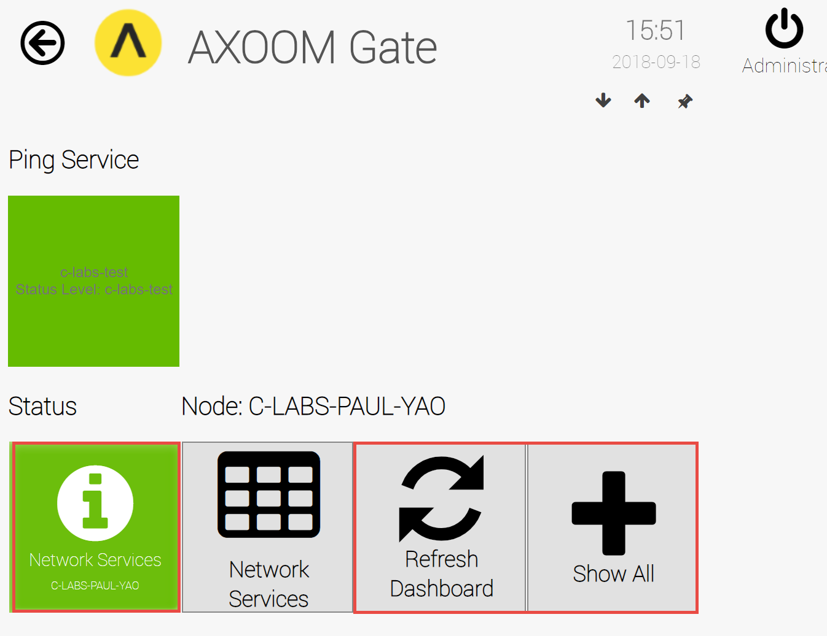
Figure 1.1. The AXOOM Virtual Things plugin dashboard.

The Plugin Dashboard
A plugin’s dashboard (see Figure 1.1) provides the primary plugin interface. All “live” items appear at the top of a plugin dashboard. A series of buttons appears at the bottom of the plugin dashboard. In the dashboard shown in Figure 1.1, red rectangles identify the three standard dashboard buttons:
1) About button: The button with the circled “i” is the About button. Click for details on the dashboard. The button color reflects the status. Status colors, associated status code, and meaning of the status, are summarized here:
  - Gray (0): Idle.
  - Green (1): Active / Ok.
  - Yellow (2): Warning.
  - Red (3): Error.
  - Blue (4): Starting / Setup / Ramp Up.
  - Brown (5): Design / Engineering / Configuration.
  - Purple (6): Shutdown.
  - Black (7): Unknown / Unreachable.
2) Refresh Dashboard button: Reloads the dashboard with latest values.
3) Show All button: Open all forms and tables associated with the plugin.

Figure 1.2 shows the default image on a table button. Click a table button to view and edit a table of items managed by the plugin. For example, you can add new items, edit existing item properties, or delete items.
Figure 1.2. Buttons with this table icon enable viewing and editing tables of plugin items.

About the Virtual Things Plugin
This chapter introduces the Virtual Things plugin and covers steps to accessing the dashboard of the Virtual Things plugin.

About the Virtual Things Plugin
The Virtual Things Plugin extends AXOOM Gate with services generate test data and to help demonstrate AXOOM Gate capabilities. Supported services include:

Virtual Thing Type | Description |  | Config Details
Countdown Timer |  | A count down timer that decrements from a starting value to zero, at a rate that you can specify. | Chapter 3
Data Generator |  | Generates test data. Can be configured to add properties and regularly update those properties. | Chapter 4
Data Verifier |  | Use with Data Generator to monitor the number of properties and rate of property updates.  ** Note: Chapter not yet written. ** | Chapter 5
Memory Tag |  | A storage location for data from plugins or services. | Chapter 6
NMI Element |  | Enables the creation of complex screens by tapping directly into the user-interface engine with no programming or custom plugins required.  ** Note: Chapter not yet written. ** | Chapter 7
Sine Wave |  | Generates trigonometric numeric values at a regular rate. | Chapter 8
Timer |  | A counter that increments at a regular rate. | Chapter 9
Virtual Sensor |  | Provides data visualization elements for a numeric value created by any object created by any plugin. | Chapter 10
Virtual State Sensor |  | Allows for filtering and preprocessing of a property value from any object created by any plugin. | Chapter 11
Data Playback |  | ** Note: Chapter not yet written. ** | Chapter 12

Login to AXOOM Gate
- Enter this URL, http://localhost:8701/nmi, in a web browser. The following login page appears:
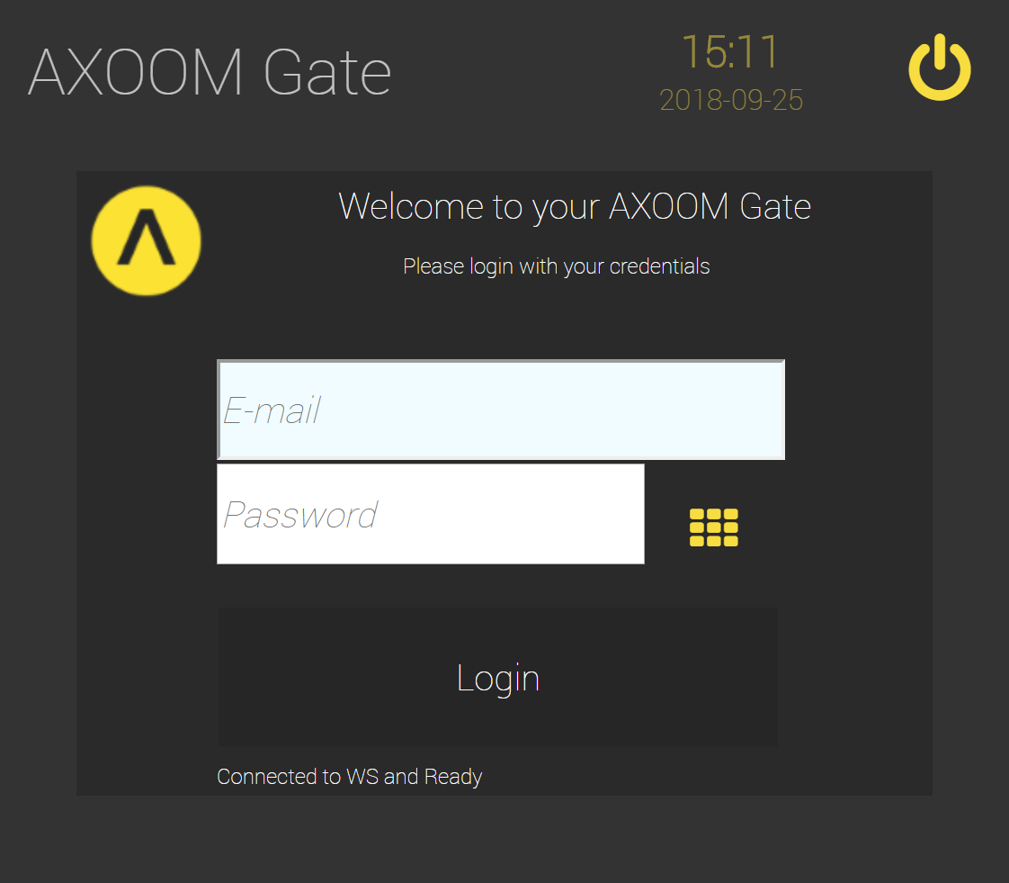
Figure 2.1. The dark scheme for the AXOOM Gate login page.
- This URL, http://localhost:8701/lnmi, enables the “light” display scheme:
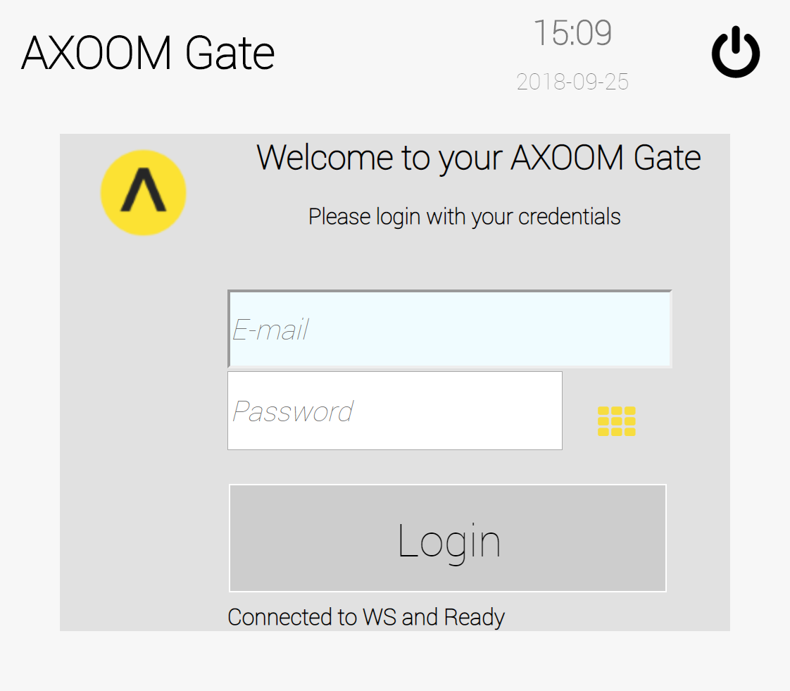
Figure 2.2. The light scheme for the AXOOM Gate login page.
- You see the AXOOM Gate home page, as shown in Figure 2.3.
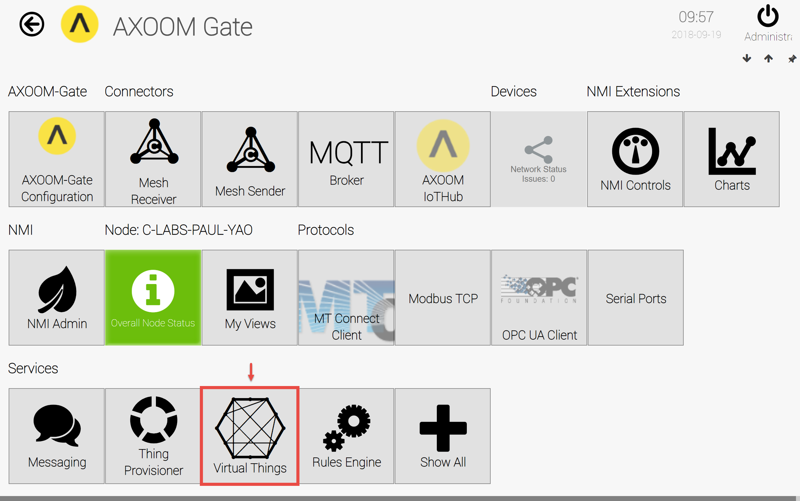
Figure 2.3. The “Virtual Things” plugin button highlighted on the AXOOM Gate home page.

Accessing the plugin dashboard
- When you click the Virtual Things plugin button, the plugin dashboard appears (see Figure 2.4).
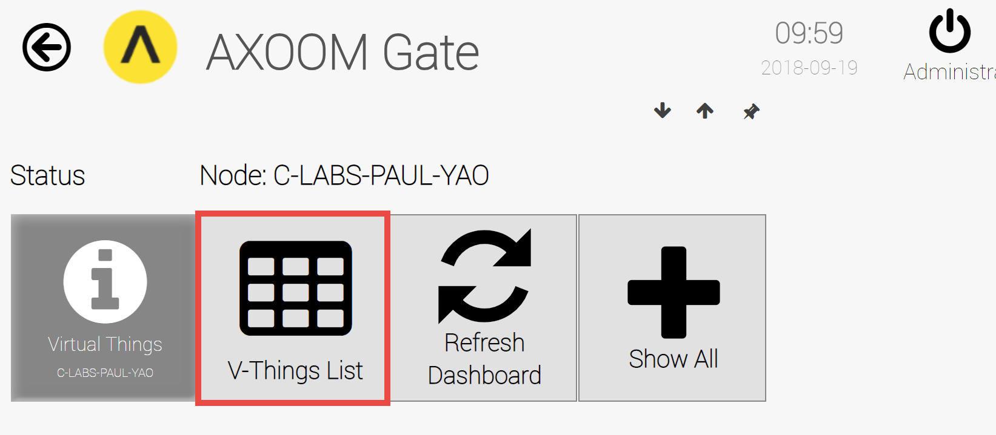
Figure 2.4. The Virtual Things Plugin dashboard.
- The Virtual Things Plugin is a client that connects with AXOOM IoTHub servers. The first step in setting up this plugin involves creating one or more connections to the appropriate servers. To do that, click the AXOOM IoTHub Connections button (highlighted in red).

Adding connections to the Virtual Things plugin
- If any connections have already been created, they will appear on the “Virtual Things” screen. No items exist in the example shown (see Figure 2.5). To add a virtual thing, click the Add a V-Thing button.
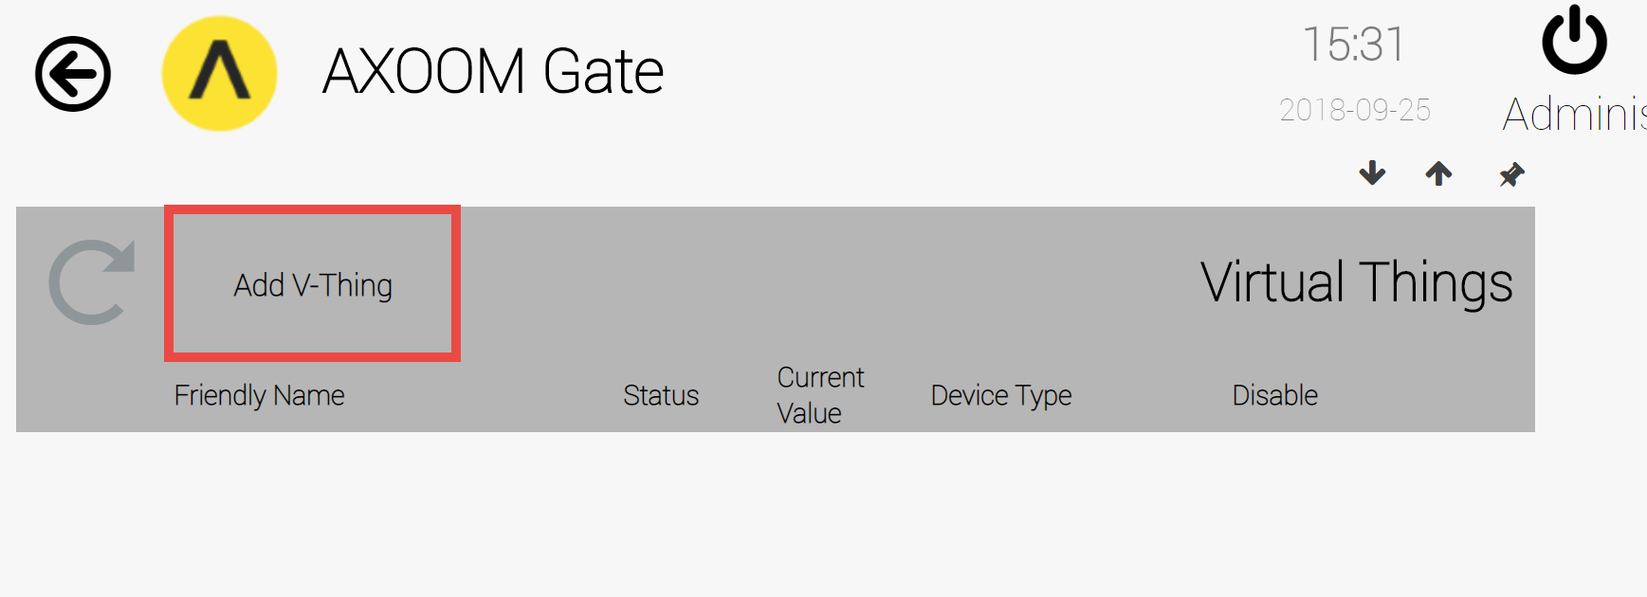
Figure 2.5. Click “Add a V-Thing” to create a virtual thing.
- An empty row appears, ready for new virtual thing (see Figure 2.6). Enter a value in the “Friendly Name” and “Address” fields, then click the checkmark () to save your work.
- A new server connection is added to the list (see Figure 2.7).
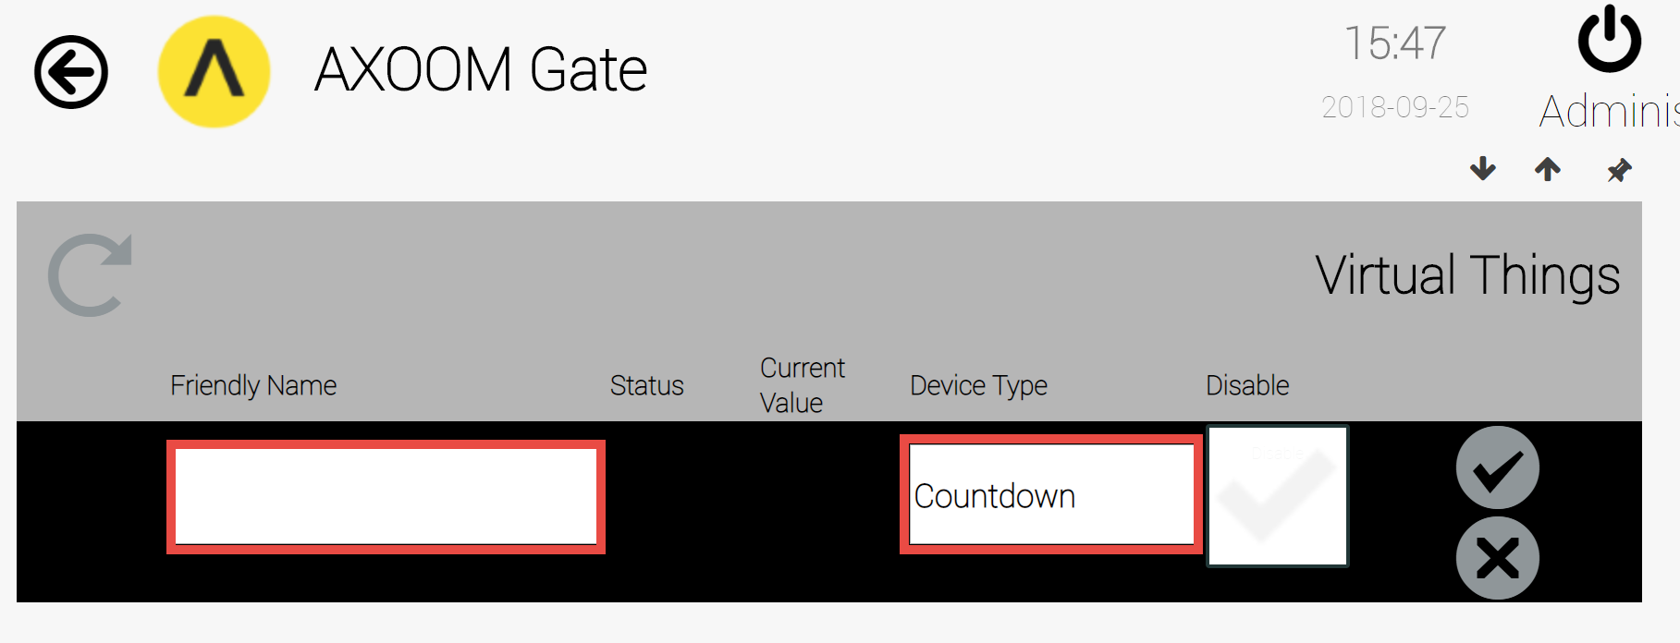
Figure 2.6. Enter Friendly Name. Click the checkmark to save.
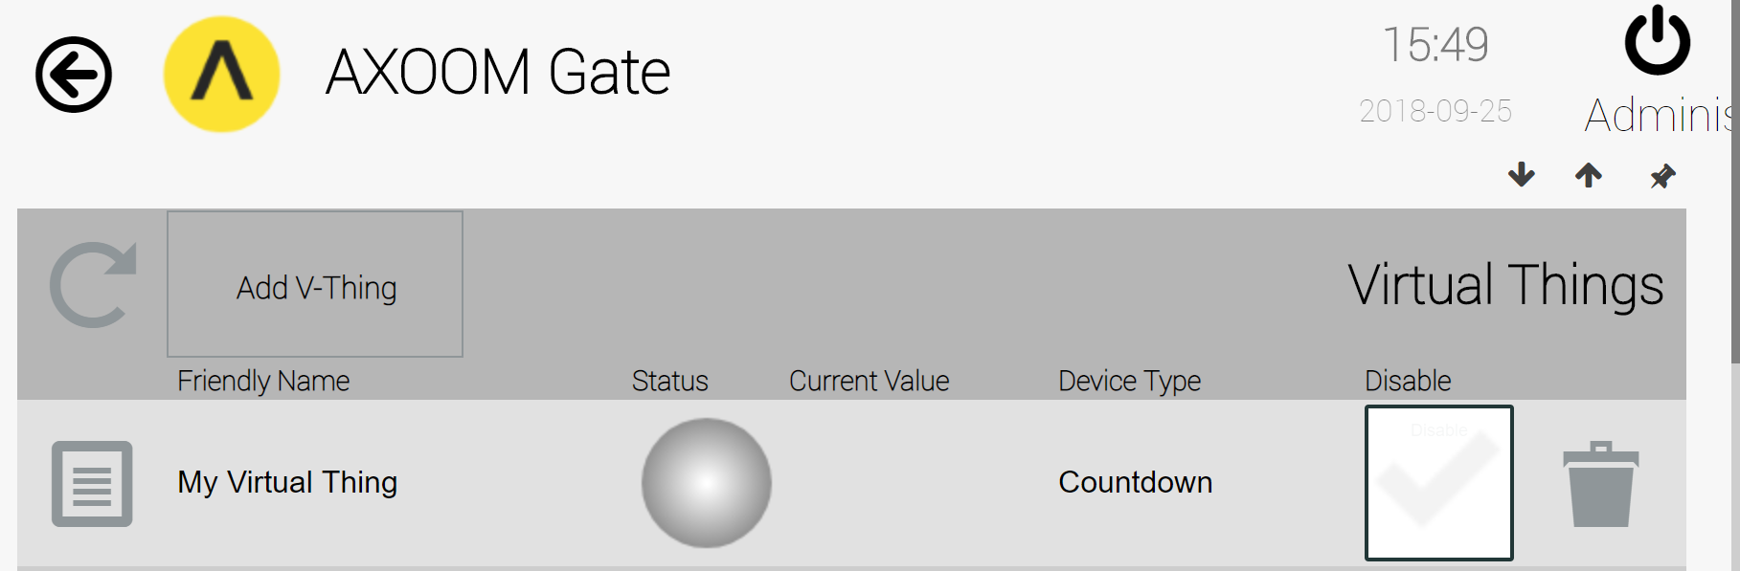
Figure 2.7. A newly created virtual thing.
Details about each column in the Virtual Things list are provided in the following table:
Column | Description
 | The Properties icon. Click to view and edit additional server settings.
Friendly Name | A name you pick. In the Device Status Group this is the Device Name.
Status | A status light, with the following meanings: gray (idle), yellow (waiting), red (error), green (connected).
Current Value | When in a running state, this value is created by the virtual thing.
Device Type | Nine possible settings:  - Countdown – Integer countdown to zero.  - Data Generator  - Data Verifier  - Memory Tag  - NMI Element  - Sine Wave – Generates values on a sine wave.  - Timer  - Virtual Sensor  - Virtual State Sensor
 | Trash can. Delete item on current row. After deleting, refresh the table by clicking the Refresh button ().

Accessing other settings groups
After you create a server table entry, click the properties button () to see more settings. As shown in Figure 2.8, when the properties page first appears, one of three settings groups is visible. Show and hide settings groups by clicking the up and down arrows. These two arrows, plus the left and right arrows, allow you to set the property groups in the browser. This table summarizes these four display buttons:
Display Buttons | Description
 | Up arrow. Closes a group.
 | Down arrow. Opens a group.
 | Left arrow. Decreases the width of browser space used to display property groups.
 | Right arrow. Increases the width of browser space used to display property groups.

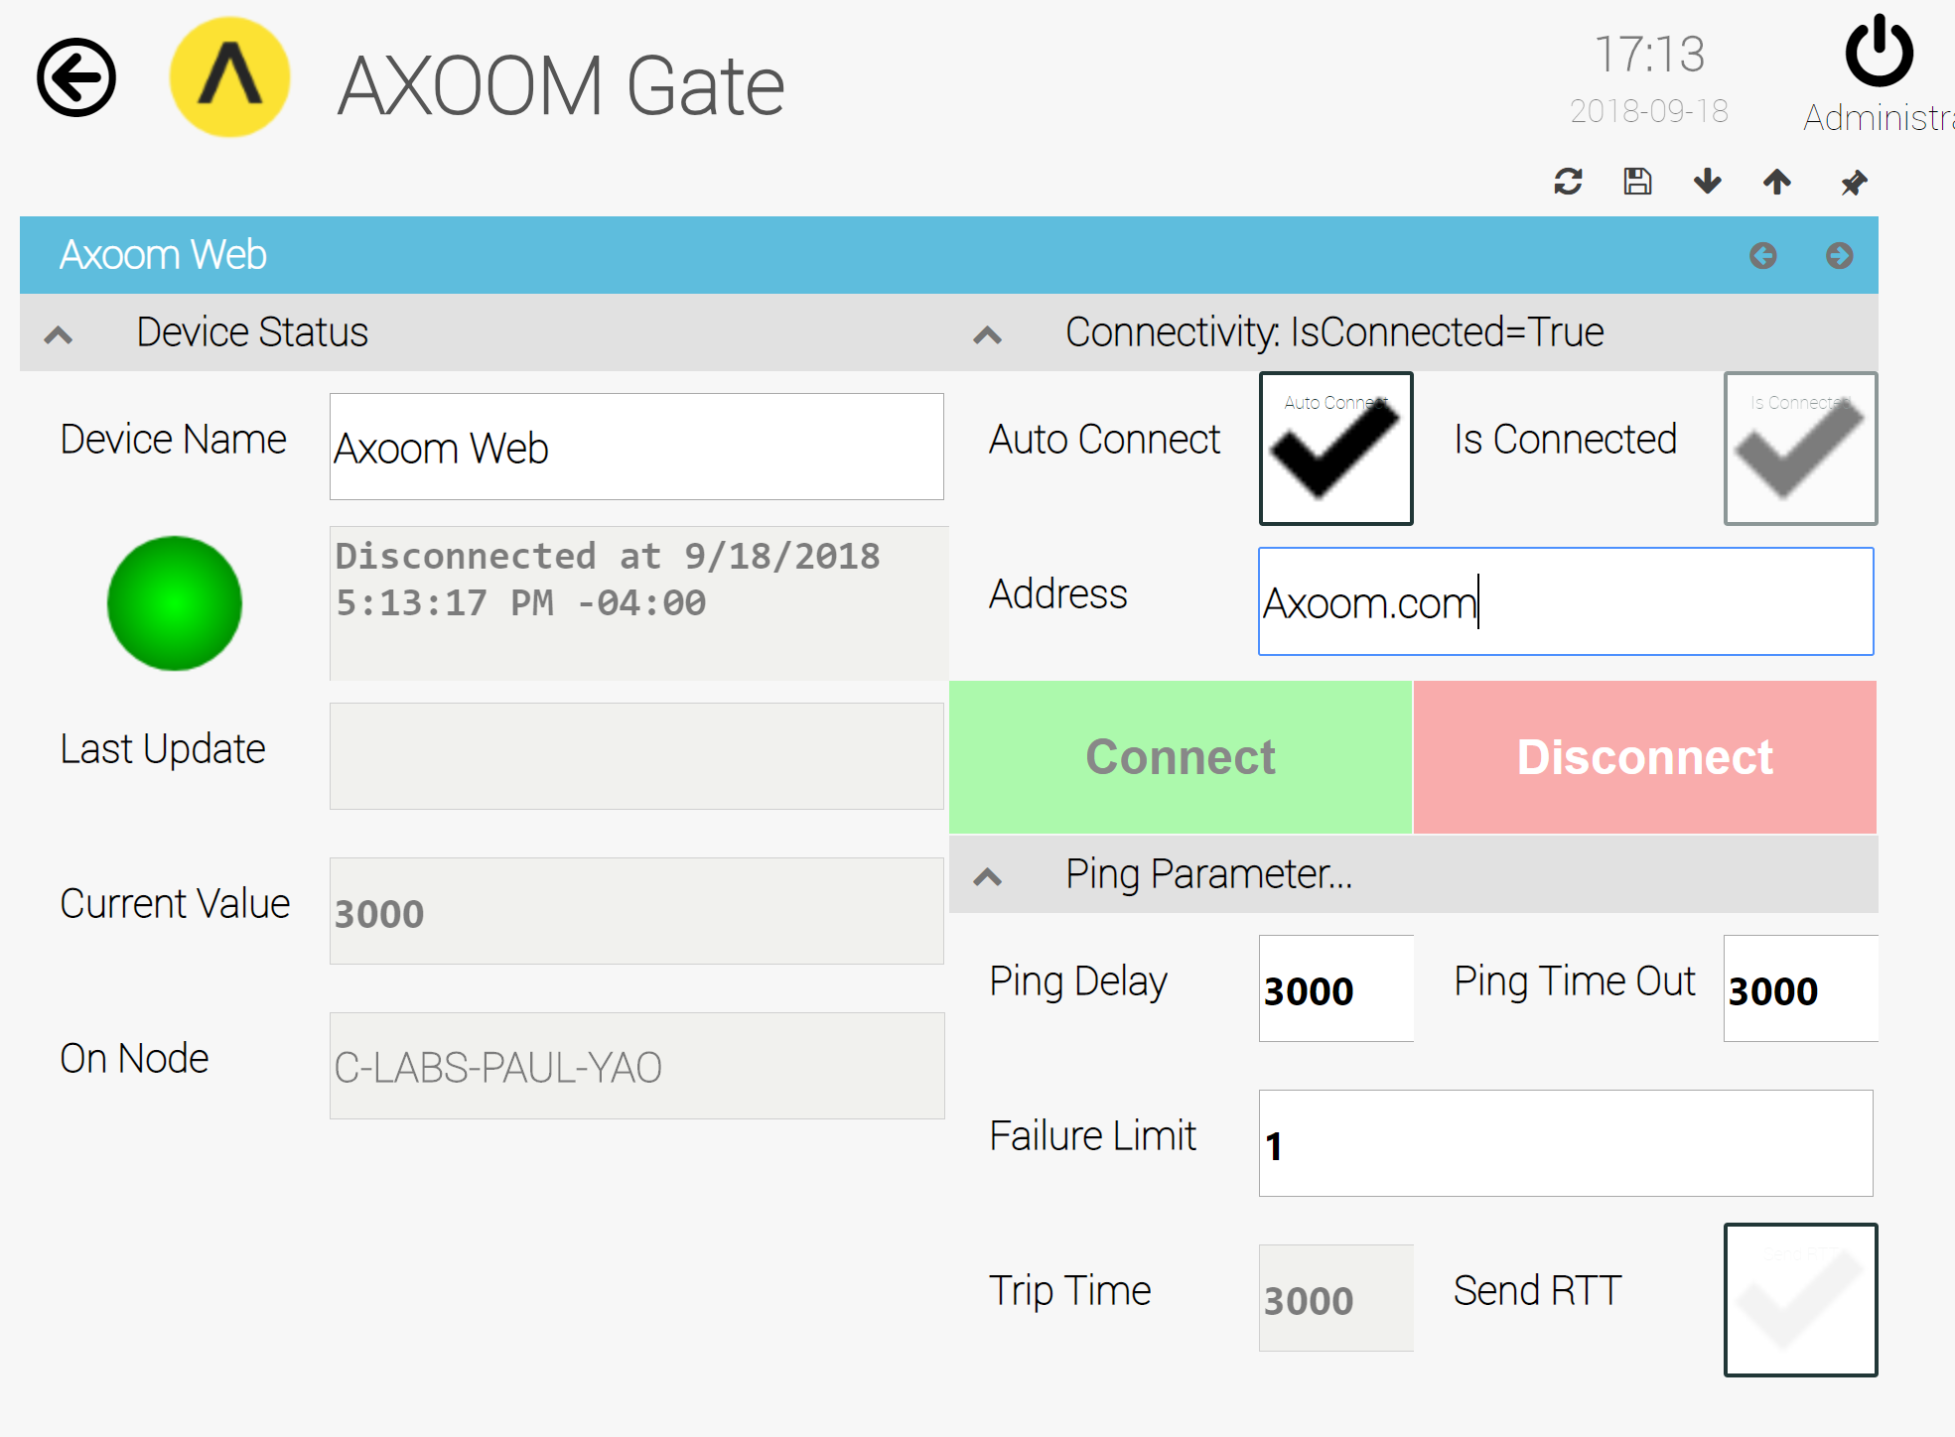
Figure 2.8. The Ping server properties page, with all parts open.
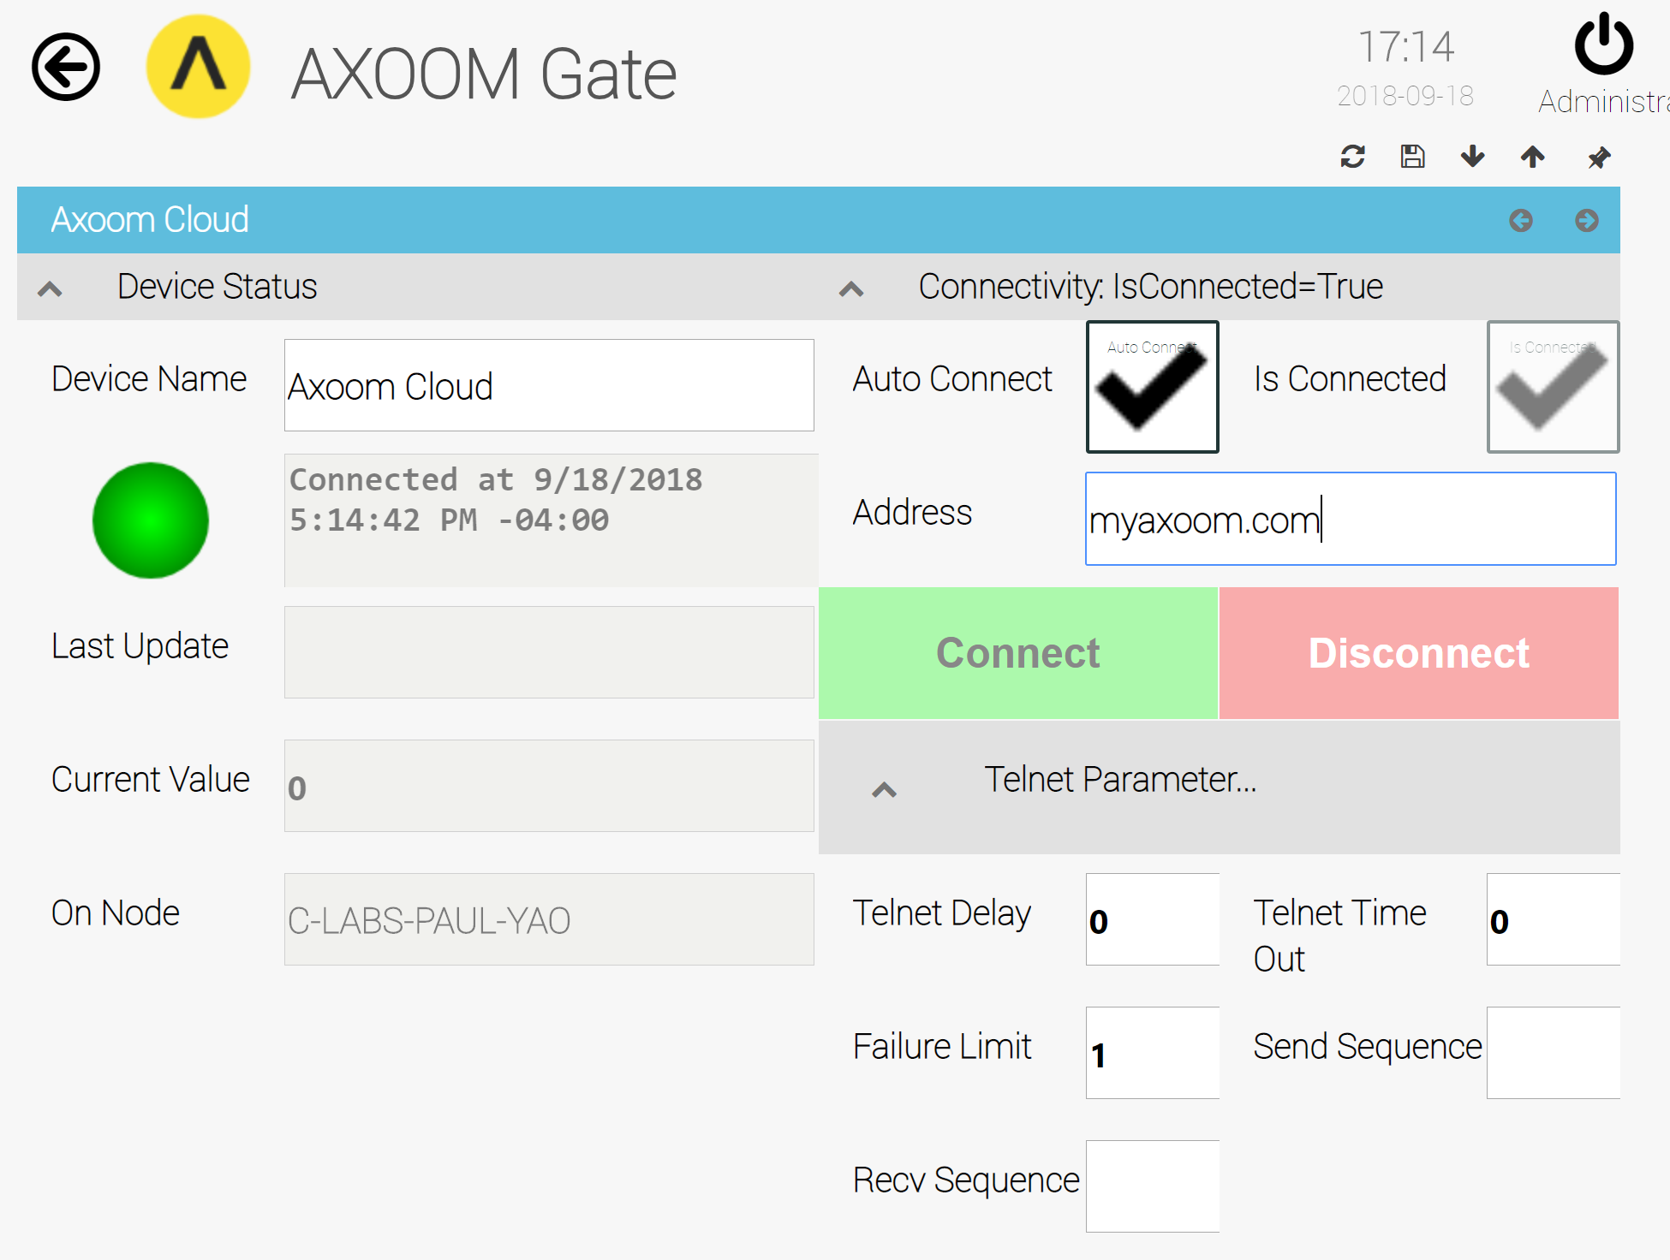
Figure 2.9. The Telnet Ping server properties page, with all parts open.
Each group is described in more detail in the sections that follow. Figure 2.9 shows the properties page when all settings groups are opened.

Device Status Group
The Device Status group (see Figure 2.10) appears by default. It holds basic plugin details, including:
- Device Name – the “Friendly Name.” You can edit this value any time.
- Status light – Green when connected; red when not connected.
- Status text – Details about the current connection when connected; details about connection errors when not connected.
- Last Update – not in use.
- Current Value –
- On Node – The name of the node where the Virtual Things plugin is running.
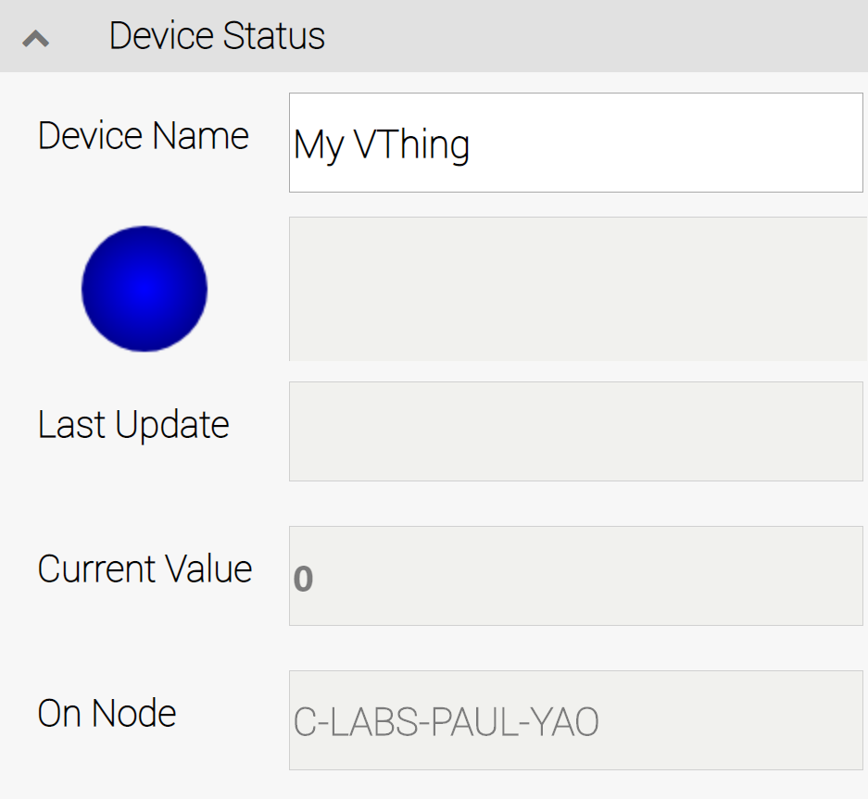
Figure 2.10. Device Status group.

Countdown Timer
A Countdown Timer is a virtual device that uses a timer to create a sequence of numbers from a defined start value down to zero.
Two related virtual devices are the Timer, which counts from zero upward, and the Sine Wave, which generates a set of values related to the trigonometric sine function.

Creating a Countdown Timer
To create a Countdown Timer, click on the Add V-Thing button in the Virtual Things table (see Figure 3.1), then select a device type of "Countdown".
Figure 3.1. The Virtual Things table.

Configuring a Countdown Timer
After creating a Countdown Timer, you need to configure it. This chapter walks through the configuring of a Countdown Timer named MyCountdownTimer. Figure 3.2 shows the timer in the Virtual Things list.
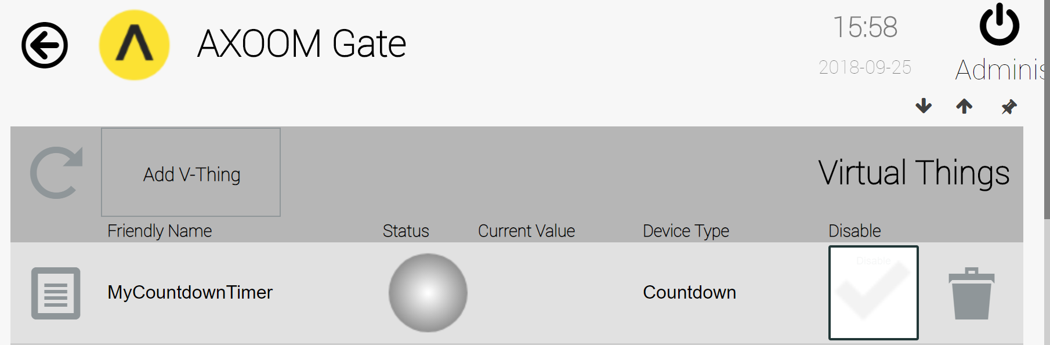
Figure 3.2. A Countdown virtual thing ready to be configured.
Click on the properties icon () on the left side of this row to summon a configuration page. Figure 3.3 shows the countdown configuration page, with all settings groups visible.
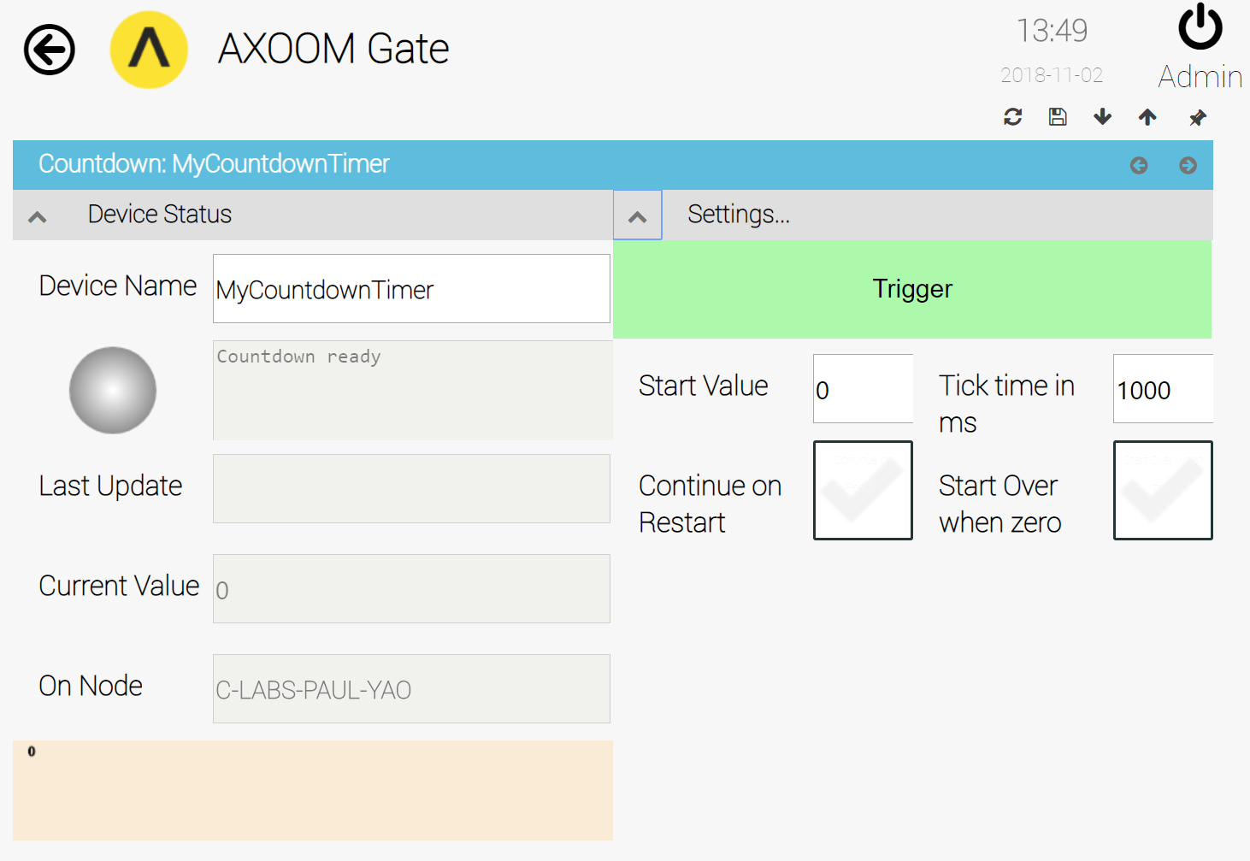
Figure 3.3. Countdown Timer virtual thing settings page with all settings groups visible.
The important settings are described in the following table:
Field Name | Description
Current Value | The current output value of the Countdown Timer. This value is also represented graphically in a bar chart on the lower left side of the settings page.
Trigger | The green Trigger button starts the Countdown Timer.
Start Value | The initial value of the Countdown Timer when it starts or restarts.
Tick time in ms | The time, in milliseconds, to delay between each decrementing of the value.
Continue on Restart | Whether to start this control automatically after AXOOM Gate restarts.
Start Over when Zero | When checked, this setting causes the Countdown Timer to run continuously. Otherwise, the countdown runs to zero a single time and then stops.

Figure 3.4 shows sample settings for the Countdown Timer. With these settings, after the user clicks the Trigger button, the value runs from 1000 to zero with 5 milliseconds between each value change.
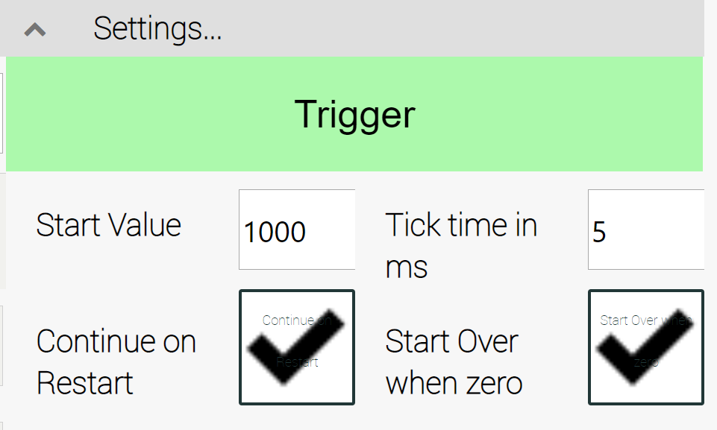
Figure 3.4. Sample settings for the countdown timer.

Live View of Countdown Timer
Figure 3.5 shows an example of the “live” view of a countdown timer in operation that appears on the dashboard of the Virtual Things plugin.

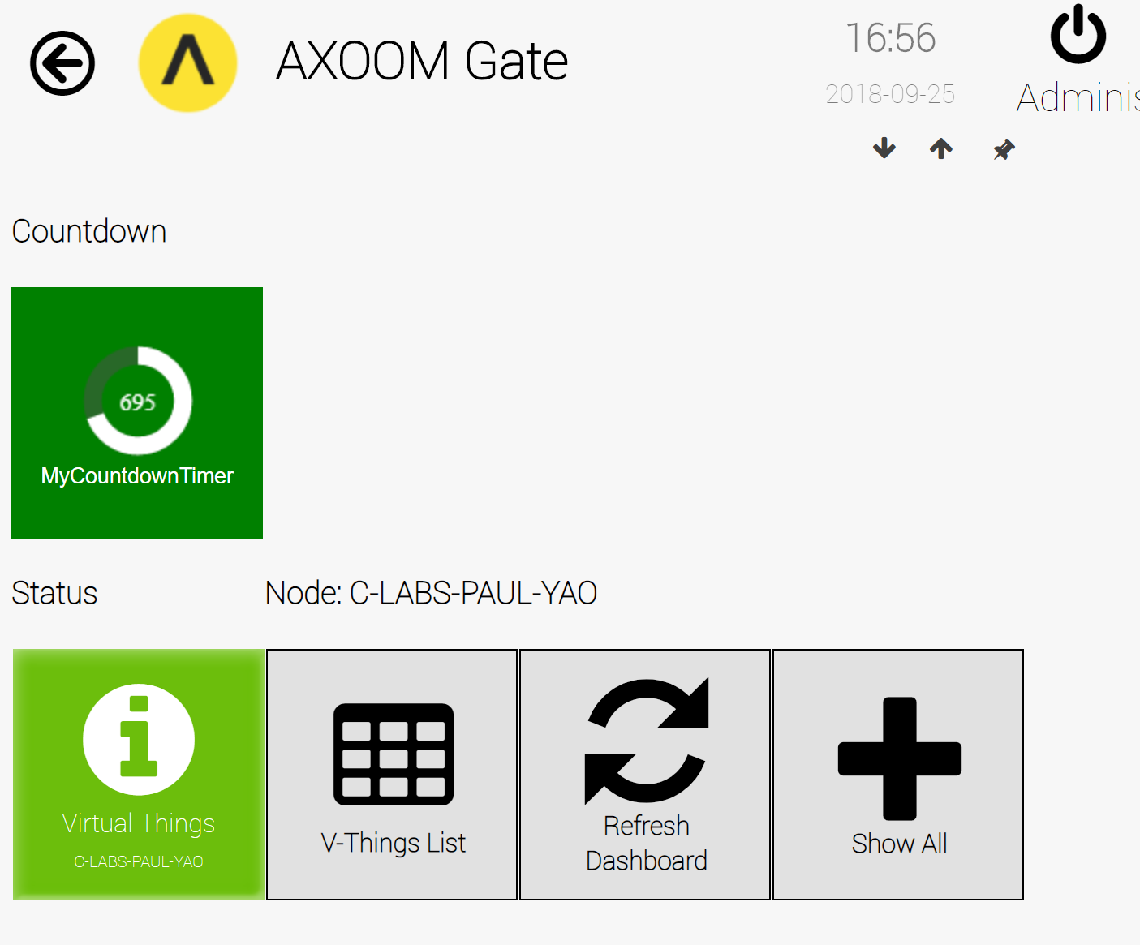
Figure 3.5. The live view of a countdown timer.

Data Generator
The Data Generator virtual device generates a set of properties without having to write any code. It has the option to update the values in the properties on a timer tick and it reports statistics on the number of property updates per second.

Creating a Data Generator
To create a Data Generator, click on the Add V-Thing button in the Virtual Things table (see Figure 4.1), then select a device type of "Data Generator".
Figure 4.1. The Virtual Things table.

Configuring a Data Generator
After creating a Data Generator, you need to configure it. This chapter walks through the configuring of a Data Generator named MyDataGenerator. Figure 4.2 shows the newly created object in the Virtual Things list.
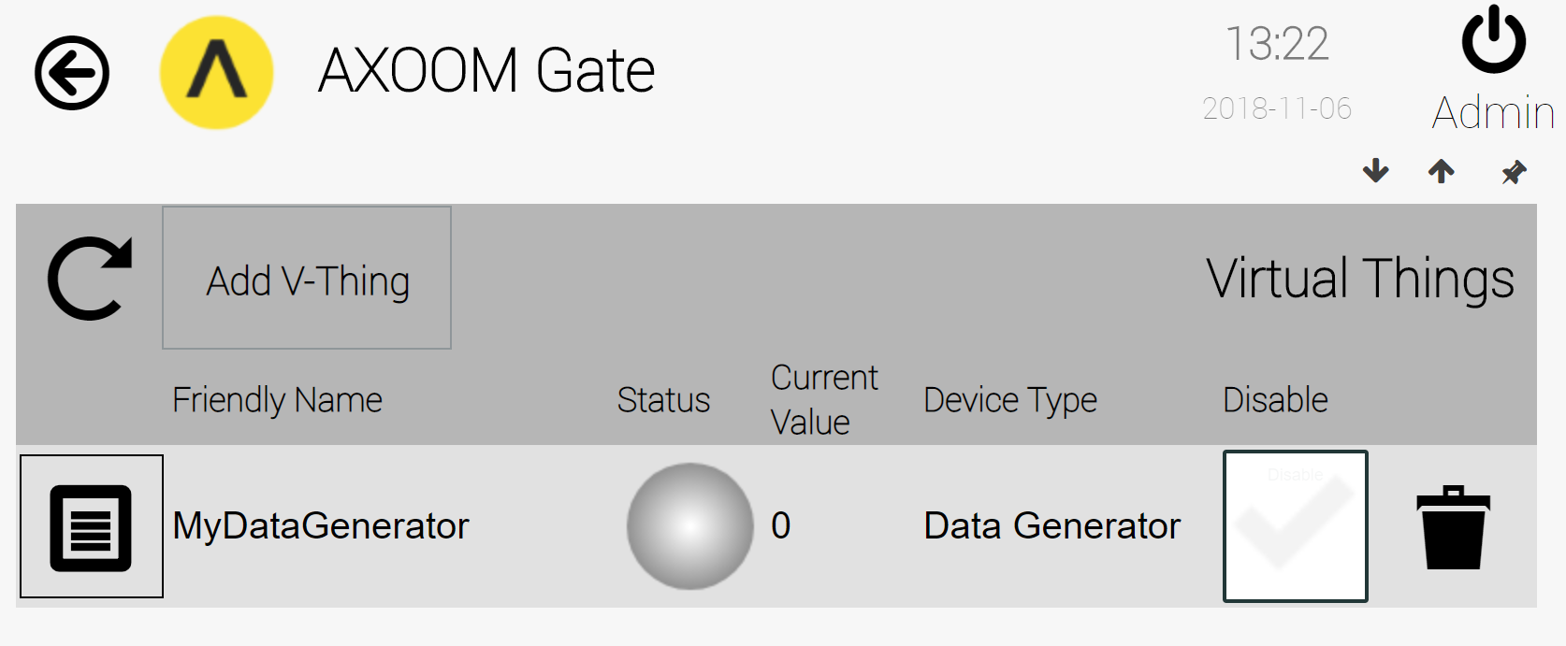
Figure 4.2. A Data Generator ready to be configured.
Click on the properties icon () on the left side of this row to summon a configuration page. Figure 4.3 shows the Data Generator configuration page, with all settings groups visible. The important settings are described in the following table:
Field Name | Description
Device Name | The friendly name of the object you are working with.
Current Value | The number of properties for the current object, including standard properties (EngineName, FriendlyName, etc.) as well as properties that are created as part of data generation.
On Node | The network name of the system on which AXOOM Gate is running.
Auto Start | When checked, the Data Generator automatically starts when AXOOM Gate is restarted.
Is Started | A read-only checkbox that indicates whether the Data Generator is currently running or not.
Start | Push this button to start generating data.
Stop | Push this button to stop generating data.
Number of Properties | The number of properties to use for data generation.
Frequency | When not zero, the time (in milliseconds) to wait between updating new values to the generated properties.
Properties per Second | A read-only field that provides statistics on the rate per second that properties have been changed.
Property Count | A read-only field that reports the count of the total number of times that property values have been set. This is not a count of properties, but instead is the count of property write operations.
Reset Counter | Push this button to reset the two counters to zero.

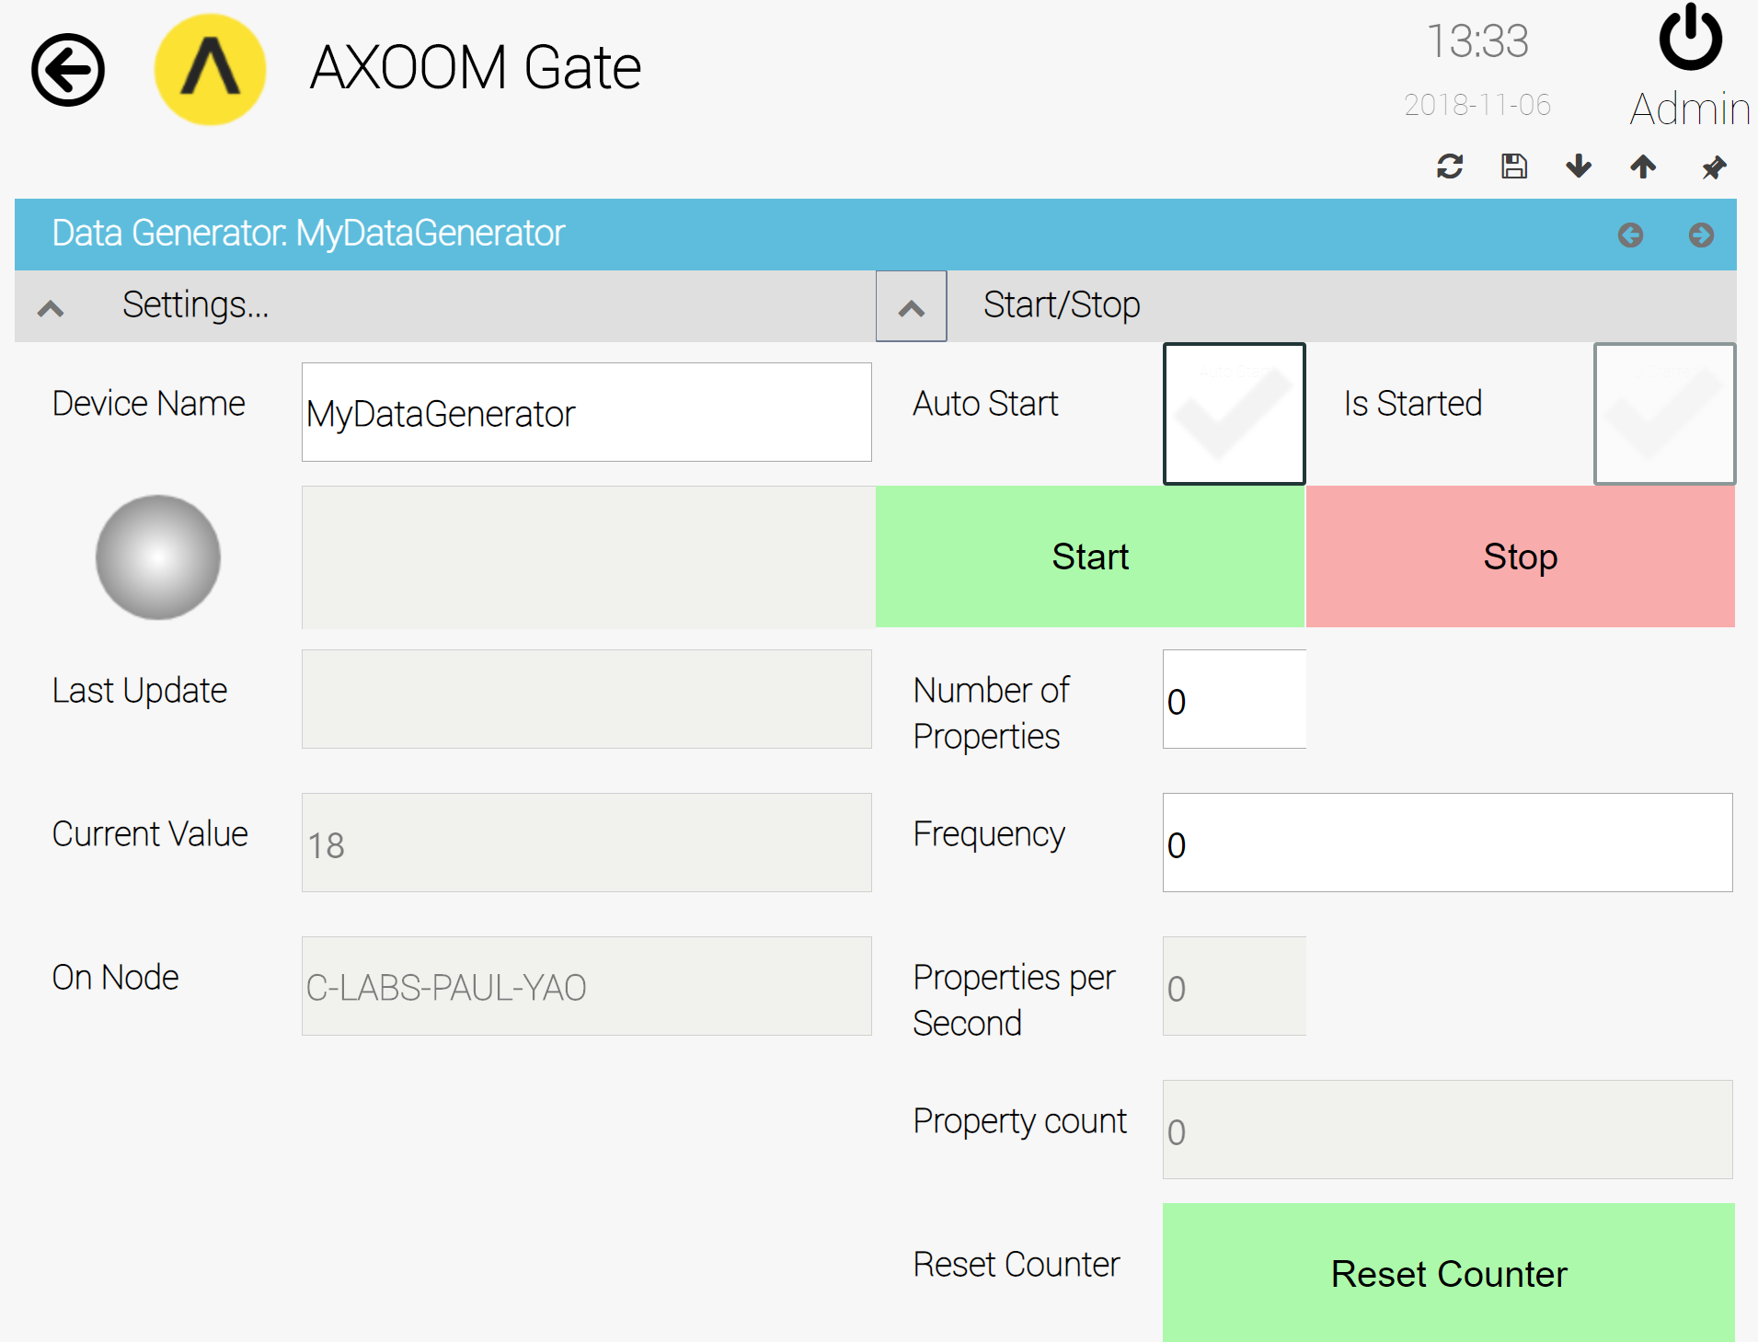
Figure 4.3. The Data Generator configuration fields.

Viewing Generated Data
The properties which are generated have names like the following template: Gen_PropXXXX, where XXXX is a number from 1 up to the number of properties that you request in the Number of Properties configuration field. For example, when five properties are requested, those five properties have the following names:
- Gen_Prop0001
- Gen_Prop0002
- Gen_Prop0003
- Gen_Prop0004
- Gen_Prop0005
You can view all of the Data Generator properties by scrolling the browser page past the configuration fields. Figure 4.4 shows the properties values for a newly-created Data Generator.
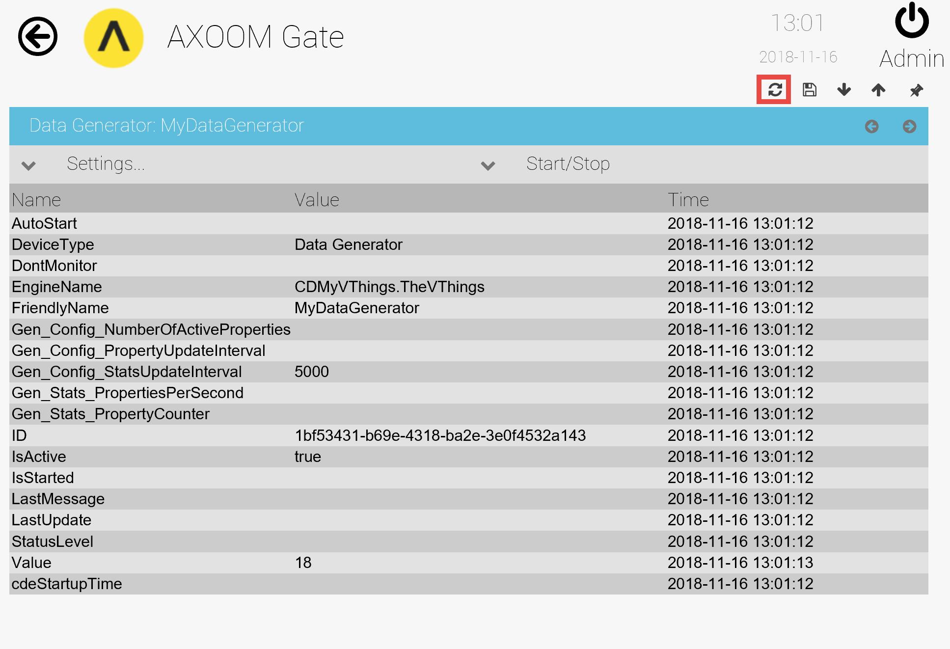
Figure 4.4. The properties of a newly-created Data Generator.
The list of properties in Figure 4.4 is a static list. After you have started generating data, refresh the Data Generator by clicking the refresh button () located in the upper-right side of the Data Generator page. Figure 4.5 shows the property list after a refresh, where the newly created properties and their current value are visible.
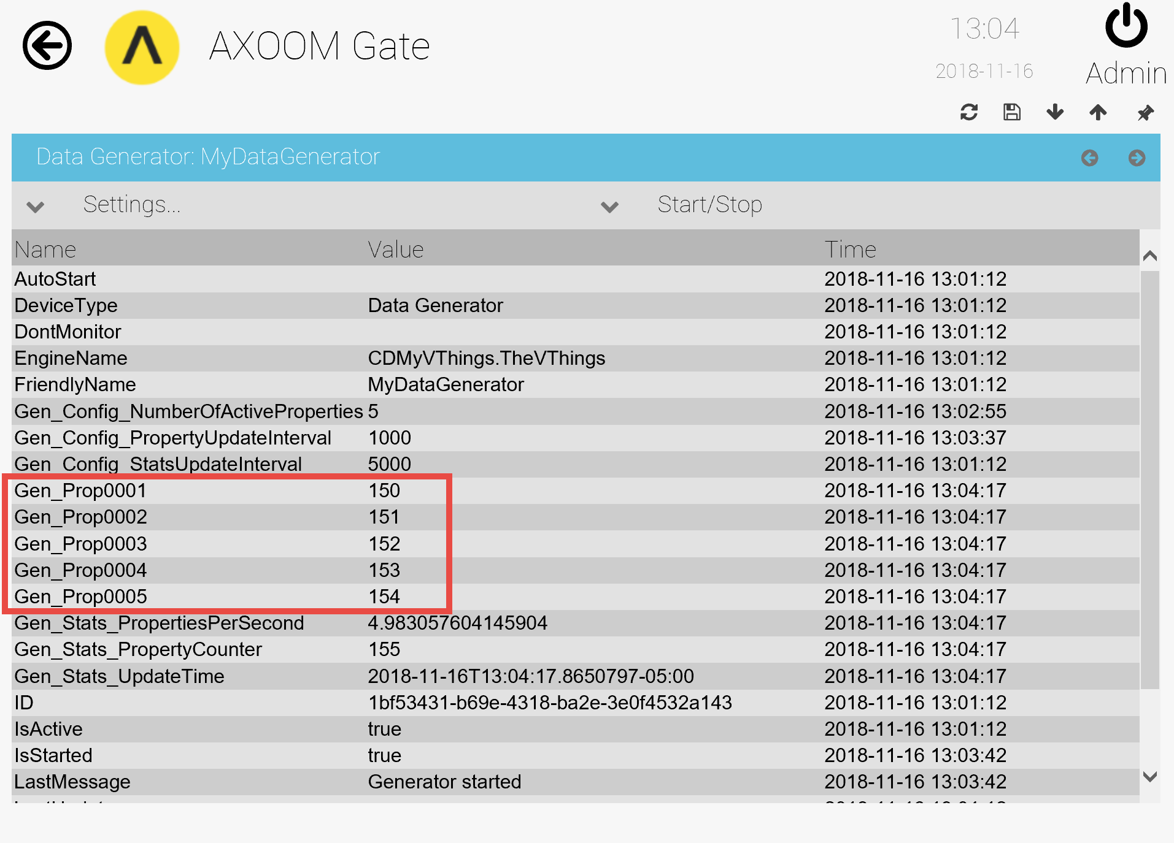
Figure 4.5. The list of Data Generator properties showing five newly-generated properties.

Data Verifier
The Data Verifier virtual thing monitors changes to thing properties for other things, counting the number of changes and reporting on the rate of change. It can be paired with the Data Generator virtual thing to stress test the C-DEngine's overall ability to modify a large number of properties at a high rate of change..

Creating a Data Verifier
To create a Data Verifier, click on the Add V-Thing button in the Virtual Things table (see Figure 5.1), then select a device type of "Data Generator".
Figure 5.1. The Virtual Things table.

Configuring a Data Verifier
After creating a Data Generator, you need to configure it. This chapter walks through the configuring of a Data Verifier named MyDataVerifier. Figure 5.2 shows the newly created object in the Virtual Things list.
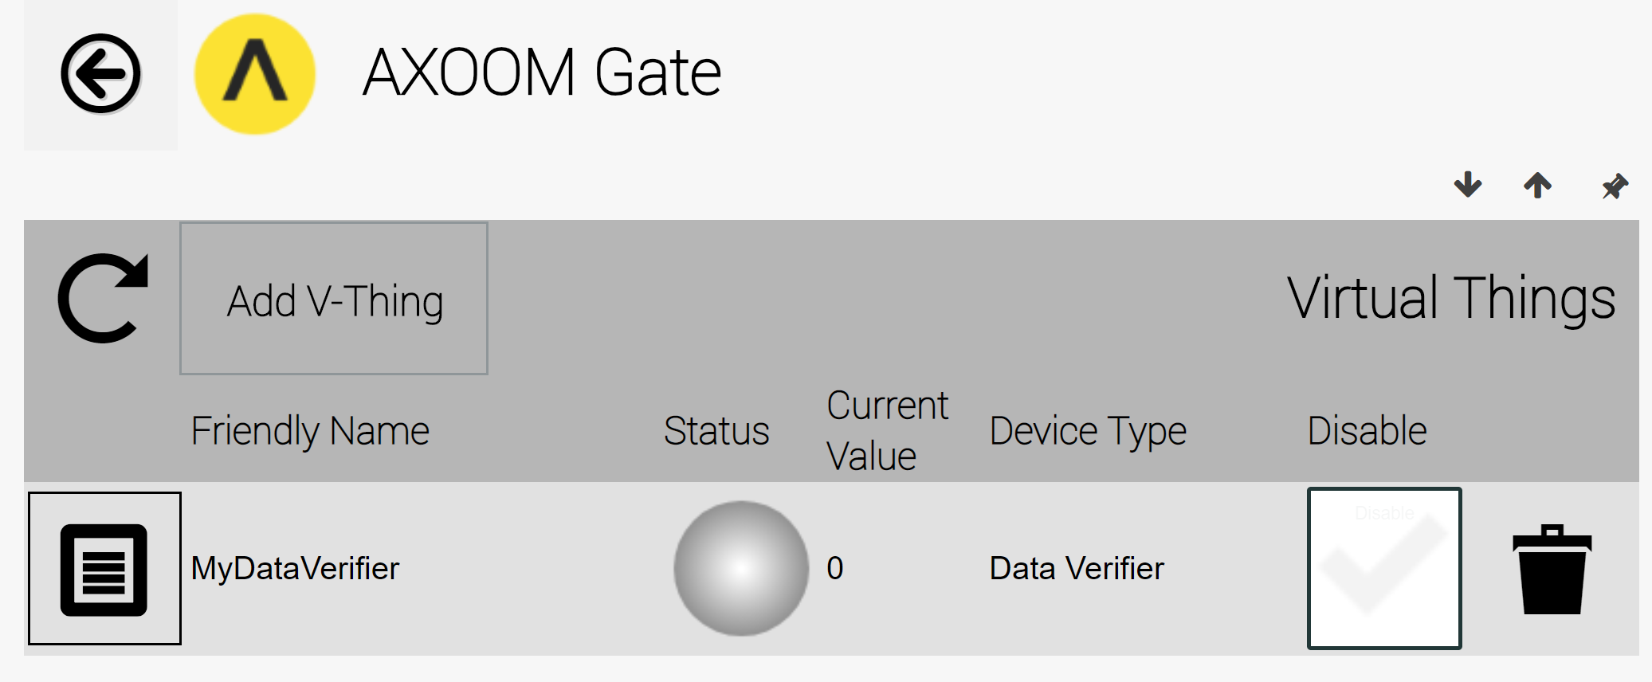
Figure 5.2. A Data Verifier ready to be configured.
Click on the properties icon () on the left side of this row to summon a configuration page. Figure 5.3 shows the Data Verifier configuration page, with all settings groups visible. The setting fields are described in the following table:
Field Name | Description
Device Name | The friendly name of the object you are working with.
Current Value | Not used.
On Node | The network name of the system on which AXOOM Gate is running.
Auto Start | When checked, the Data Verifier automatically starts when AXOOM Gate is restarted.
Is Started | A read-only checkbox that indicates whether the Data Verifier is currently running or not.
Start | Push this button to start data verification.
Stop | Push this button to stop data verification.
Number of Properties | The number of properties to monitor.
Thing for Property Sub | A thing picker control for selecting the thing to be monitored.
Properties per Second | A read-only field that provides statistics on the rate per second that properties have been changed.
Property Counter | A read-only field that reports the count of the total number of times that property values have changed. This is not a count of properties, but instead is the count of property changes.
Minimum Latency (ms) | The minimum latency in detecting property changes.
Maximum Latency (ms) | The maximum latency in detecting property changes.

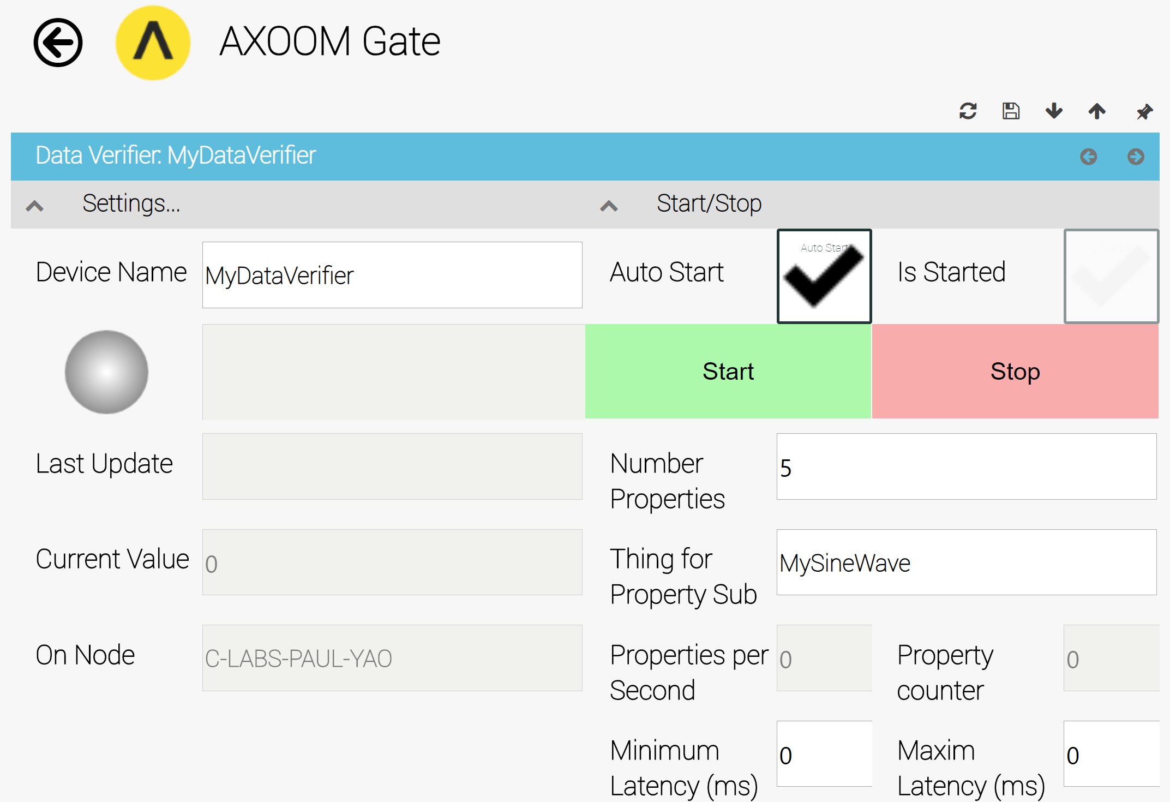
Figure 5.3 Data Verifier Configuration Page

Memory Tag
A Memory Tag is a virtual thing that you can create to centralize the capture of operational data. A Memory Tag is an AXOOM Gate object (or "thing") that can hold any number of property-name / property-value pairs. You can create a Memory Tag to hold the output of one plugin and the input to another plugin.

Memory Tags have an important benefit in that the Virtual Things plugin, as part of the core system, will always be loaded into memory and ready to use before any other plugin. Therefore, when moving data from one plugin to another, the use of Memory Tags eliminates potential problems that can occur because of load-ordering issues between two or more plugins. The hand-off of data between plugins is simplified because two cooperating plugins that communicate using a Memory Tag have a guaranteed connection between them.

Creating a Memory Tag
To create a memory tag, navigate to the V-Things List. Click on the Add V-Things button (see Figure 6.1). Enter a Friendly Name, select a Device Type of "Memory Tag", then click the checkmark button () to save.

Figure 6.1. Create a Memory Tag by clicking the Add V-Things button on the Virtual Things table.

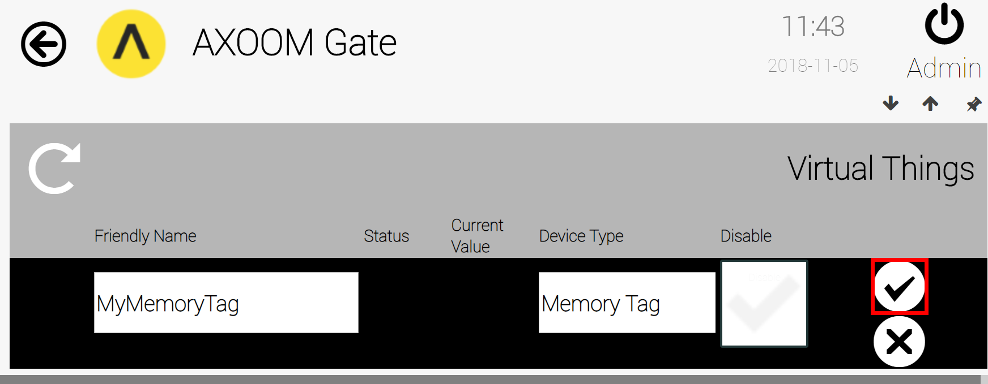
Figure 6.2. Click the checkmark to save.

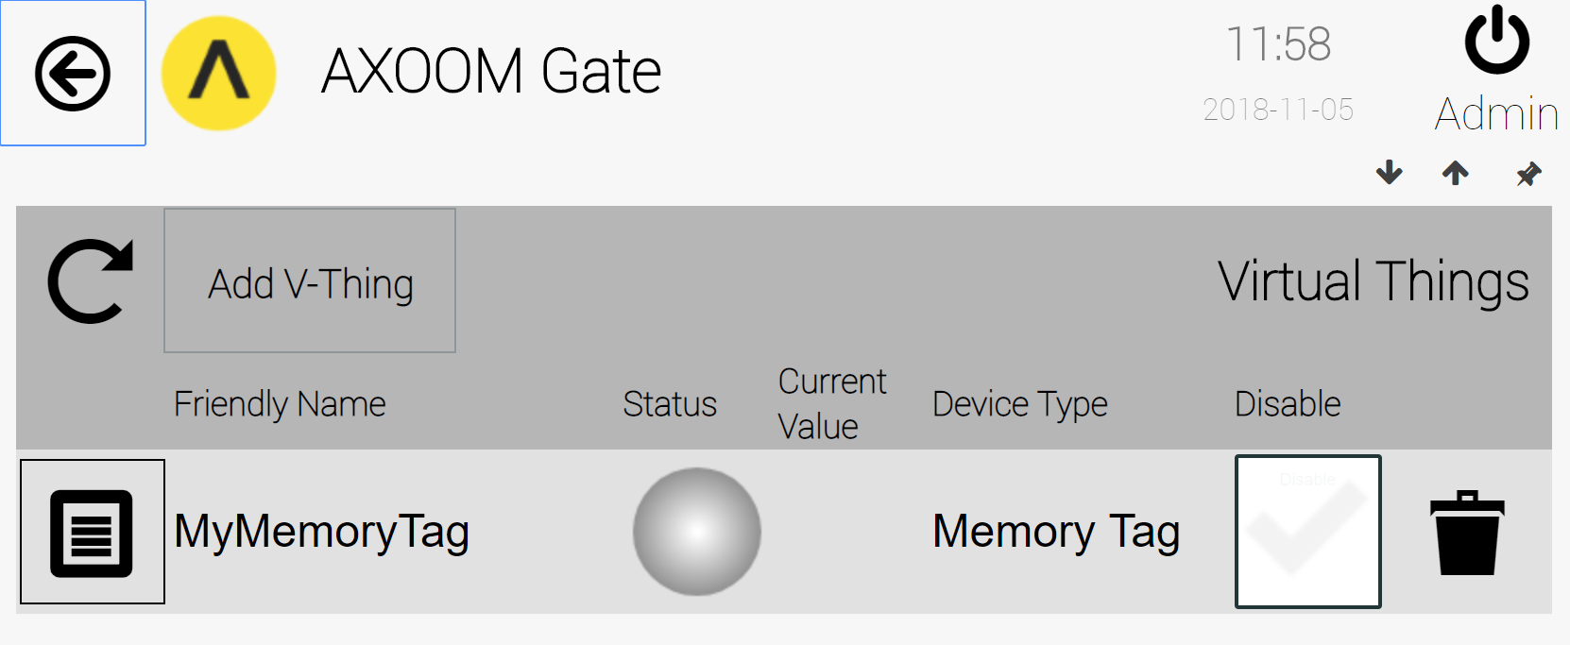
Figure 6.3. The newly-created Memory Tag.

Configuring a Memory Tag
Click on the settings (or properties) icon () on the left side of the Virtual Things table and the configuration page for the Memory Tag appears (see Figure 6.4). This table shows the name and value of all properties for the Memory Tag. Notice that the Friendly Name that identifies the Memory Tag is also included in the list of properties.

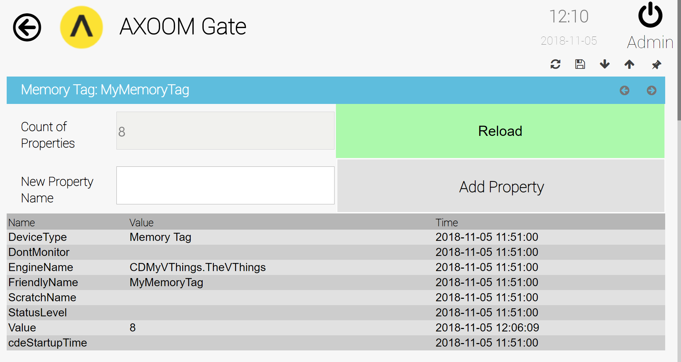
Figure 6.4. The settings page for the Memory Tag virtual thing.

Most of the items on the configuration page are read-only and exist for reference purposes. Two exceptions are the New Property Name field and the Add Property button. You can use these two fields to create new properties.

Using a Memory Tag
To use a Memory Tag, you configure one or more plugins that ask for you to provide either a "Thing" or an "Object." For example, Figure 6.5 shows a portion of a configuration page for the Rules Engine plugin. The field labeled "Action Object" is an example of one place where a Memory Tag could be used.
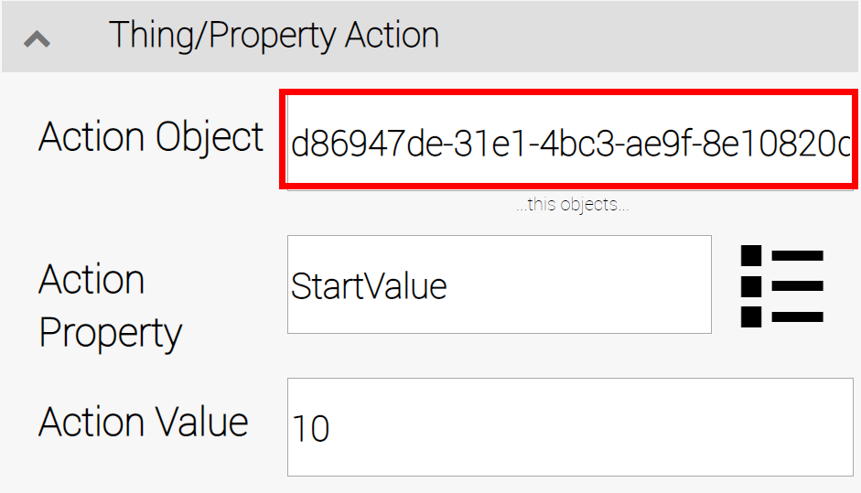
Figure 6.5. An example of a plugin field where a Memory Tag could be used.

To start the object selection process, click in a field that is expecting an object. A lookup table like that shown in Figure 6.6 may appear. If that happens, use the mouse (or a touch-screen) to scroll the two selection lists until you find the Memory Tag that you are looking for.
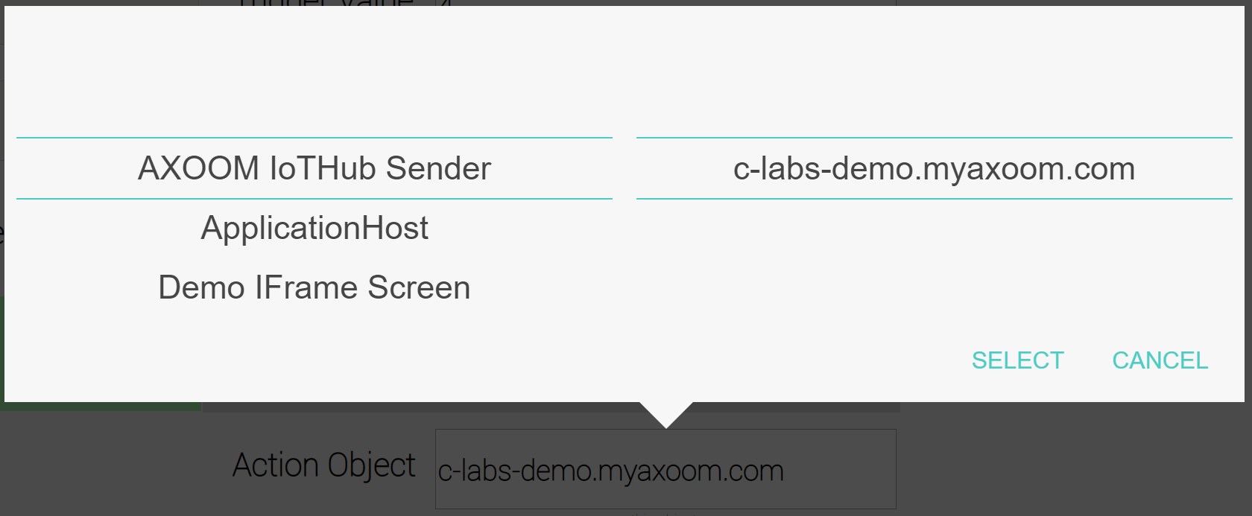
Figure 6.6. The Object Lookup table.
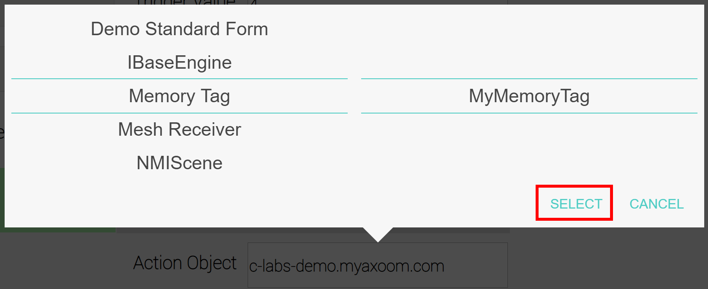
Figure 6.7. Our Memory Tag, ready to be selected in the object field.
When you find the Memory Tag (or other type of object) that you are looking for, click the SELECT button (see Figure 6.7).
It's worth pointing out that you might see the message "Select to Load Lookup Table", as shown in Figure 6.8 and Figure 6.9. This message means that the lookup table needs to be loaded.
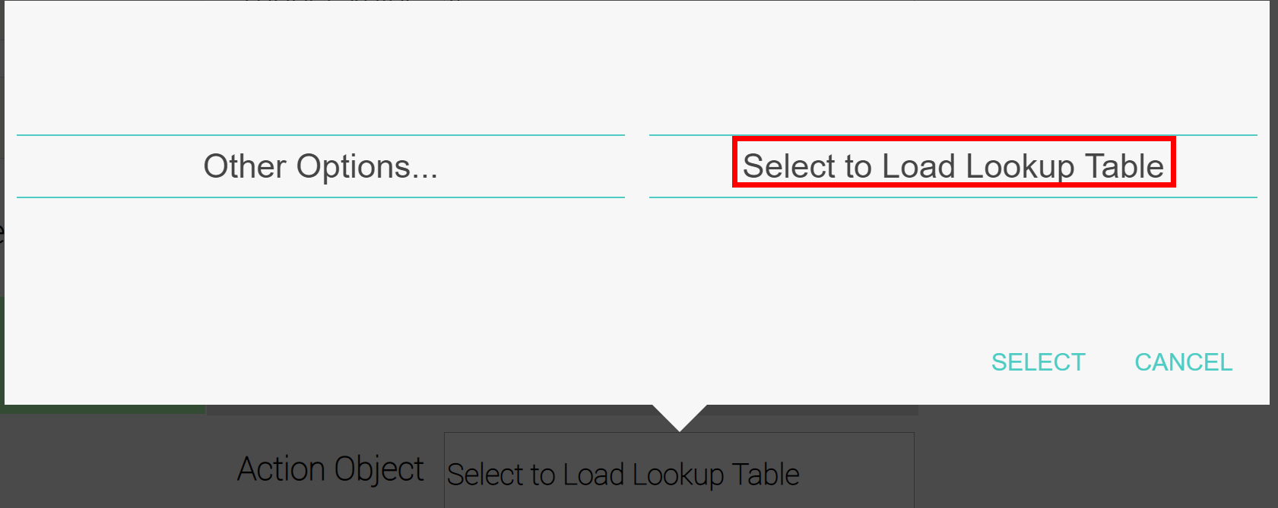
Figure 6.8. A message that can appear when the object lookup table needs to be loaded.
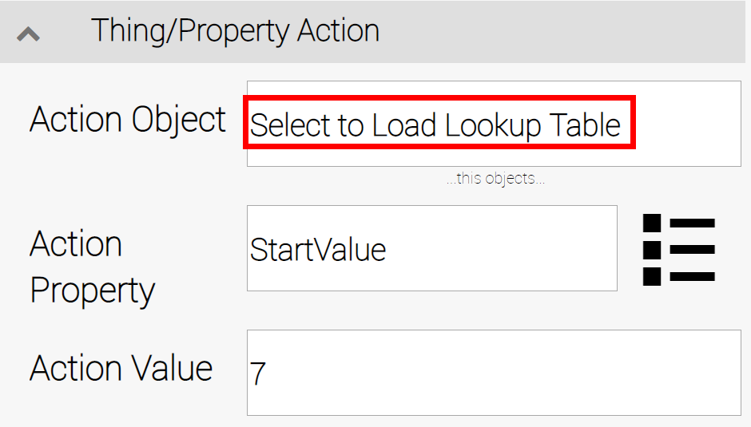
Figure 6.9. The Select to Load Lookup Table message can appear within an object selection field.
To load the lookup table, click within the selection field (Figure 6.9), or on the SELECT button (Figure 6.8) to continue with identifying the specific object that you wish to work with.

NMI Element
The NMI Element virtual thing provides a convenient way to explore the supported set of C-DEngine user-interface controls.

Creating an NMI Element
To create an NMI Element virtual thing, click the "Add V-Thing" button in the Virtual Things table (see Figure 7.1), then select a device type of "NMI Element".
Figure 7.1. The Virtual Things table.

Configuring an NMI Element Virtual Thing
After creating an NMI Element virtual thing, you need to configure it. This chapter walks through the configuring of three NMI Element virtual things named MyNMI1, MyNMI2, and MyNMI3. Figure 7.2 shows MyNMI1, MyNMI2, and MyNMI3 in the Virtual Things list. (Also shown is a Sine Wave virtual thing, SineQuaNon, which is used in this example to generate data for display in the NMI Elements.
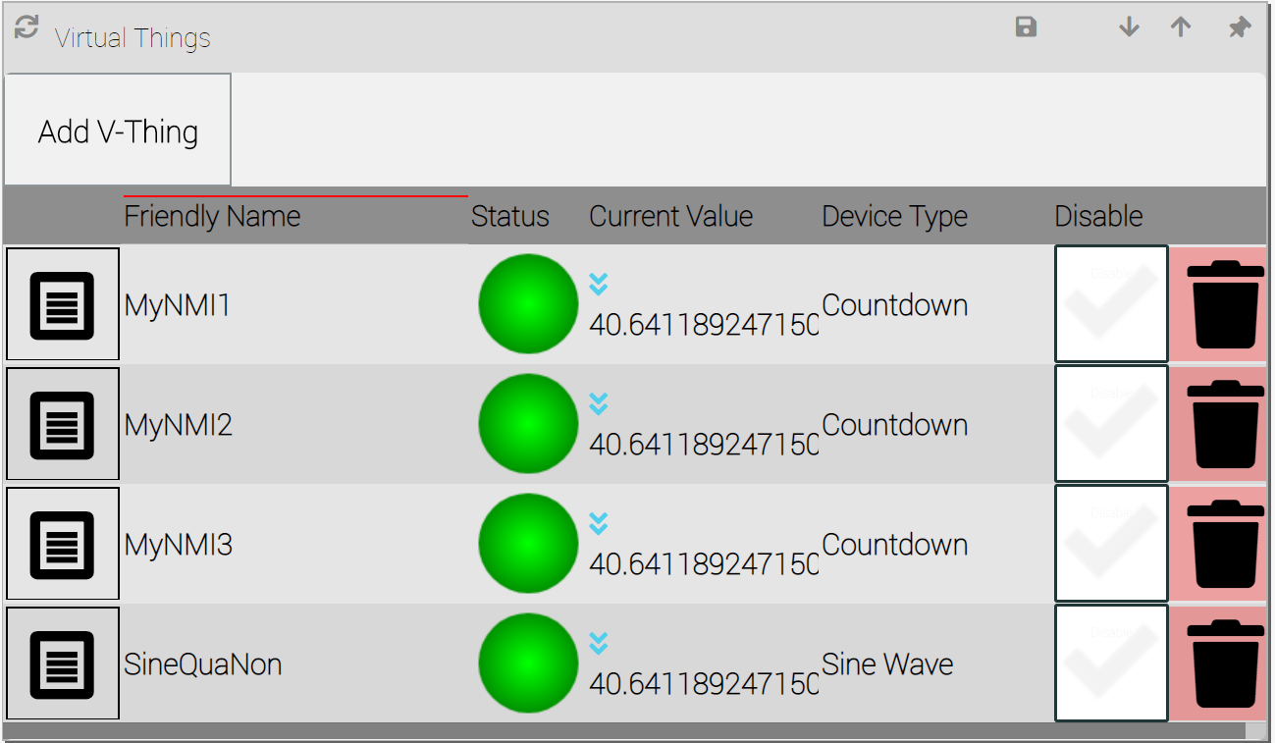
Figure 7.2. Three NMI Element virtual things ready to be configured.
Click on the properties icon () on the left side of each row to summon a configuration page. Figure 7.3 shows the NMI Element configuration page, with all settings groups visible. The five different configuration settings groups for NMI Elements are described in the following table:
Group Name | Description
Configuration | The top-level group that wraps around all other groups.
Device Status | Common configuration settings.
NMI Settings | Holds all control configuring details, including the "All Properties" and "Advanced NMI Settings" settings groups.
All Properties | Access a control's properties.
Advanced NMI Settings | The time, in milliseconds, to wait between calculations.
Source | A floating-point number for incrementing the input value to the sine function. If set to zero, the value of 1 is used.

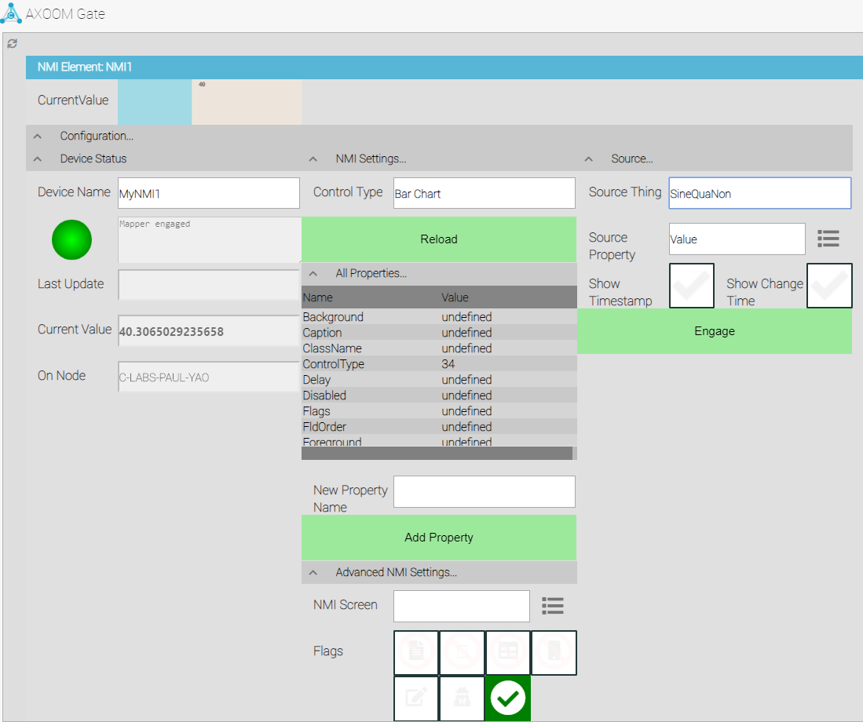
Figure 7.3. NMI Element virtual thing settings page with all settings groups visible.

Configuration Settings Group
The Configuration Settings group is the topmost container for all other configuration groups.

Device Status Settings Group
The Device Status Settings group has fields that are common to most C-DEngine things.
Click on the properties icon () on the left side of this row to summon a configuration page. Figure 7.3 shows the countdown configuration page, with all settings groups visible. The important settings are described in the following table:
Field Name | Description
Current Value | The current output value of the countdown timer. This value is also represented graphically in a bar chart on the lower left side of the settings page.
Trigger | The green Trigger button starts the sine wave timer.
Stop | The red Stop button stops the sine wave timer.
Tick time in ms | The time, in milliseconds, to wait between calculations.
Step | A floating-point number for incrementing the input value to the sine function. If set to zero, the value of 1 is used.
Amplitude | The range of values for the output value. Any value less than 10 results in the use of 10 as the amplitude. At this setting (with a shift value of 0), output values range from -5 to 5.
Shift | A positive value to be used as the middle of the range of output values. In other words, a value added to the output value to shift the range of output values outside the default -5 to +5. For example, 1 shift value of 100 (with an amplitude of 10) results in output values from 95 to 105.
Autostart | Whether to start this control automatically after AXOOM Gate restarts.

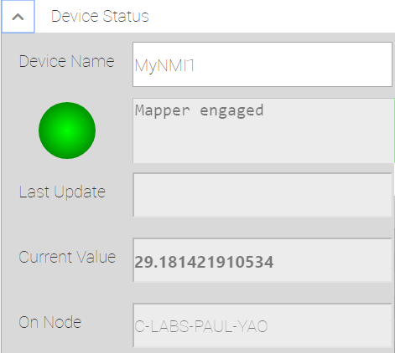
Figure 7.4. Device Status settings.
Click on the properties icon () on the left side of this row to summon a configuration page. Figure 7.3 shows the countdown configuration page, with all settings groups visible. The important settings are described in the following table:
Field Name | Description
Current Value | The current output value of the countdown timer. This value is also represented graphically in a bar chart on the lower left side of the settings page.
Trigger | The green Trigger button starts the sine wave timer.
Stop | The red Stop button stops the sine wave timer.
Tick time in ms | The time, in milliseconds, to wait between calculations.
Step | A floating-point number for incrementing the input value to the sine function. If set to zero, the value of 1 is used.
Amplitude | The range of values for the output value. Any value less than 10 results in the use of 10 as the amplitude. At this setting (with a shift value of 0), output values range from -5 to 5.
Shift | A positive value to be used as the middle of the range of output values. In other words, a value added to the output value to shift the range of output values outside the default -5 to +5. For example, 1 shift value of 100 (with an amplitude of 10) results in output values from 95 to 105.
Autostart | Whether to start this control automatically after AXOOM Gate restarts.

NMI Settings Group

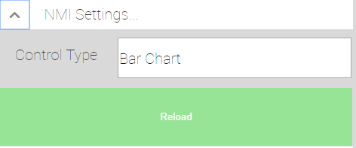

All Properties Group

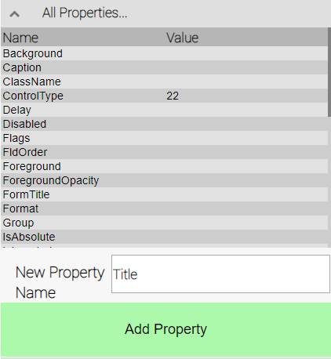
Figure 7.5. All Properties settings.
Click on the properties icon () on the left side of this row to summon a configuration page. Figure 7.3 shows the countdown configuration page, with all settings groups visible. The important settings are described in the following table:
Field Name | Description
Current Value | The current output value of the countdown timer. This value is also represented graphically in a bar chart on the lower left side of the settings page.
Trigger | The green Trigger button starts the sine wave timer.
Stop | The red Stop button stops the sine wave timer.

Advanced NMI Settings Group

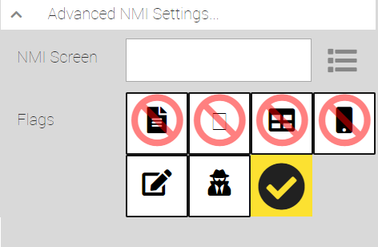
Figure 7.6. Advanced NMI Settings
Click on the properties icon () on the left side of this row to summon a configuration page. Figure 7.3 shows the countdown configuration page, with all settings groups visible. The important settings are described in the following table:
Field Name | Description
Current Value | The current output value of the countdown timer. This value is also represented graphically in a bar chart on the lower left side of the settings page.
Trigger | The green Trigger button starts the sine wave timer.
Stop | The red Stop button stops the sine wave timer.
Tick time in ms | The time, in milliseconds, to wait between calculations.
Step | A floating-point number for incrementing the input value to the sine function. If set to zero, the value of 1 is used.

Source Group

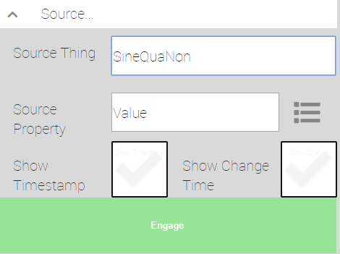
Figure 7.7. Source settings.
Click on the properties icon () on the left side of this row to summon a configuration page. Figure 7.3 shows the countdown configuration page, with all settings groups visible. The important settings are described in the following table:
Field Name | Description
Current Value | The current output value of the countdown timer. This value is also represented graphically in a bar chart on the lower left side of the settings page.
Trigger | The green Trigger button starts the sine wave timer.
Stop | The red Stop button stops the sine wave timer.
Tick time in ms | The time, in milliseconds, to wait between calculations.
Step | A floating-point number for incrementing the input value to the sine function. If set to zero, the value of 1 is used.

Sine Wave
A Sine Wave is a virtual device that generates a set of values related to the trigonometric sine function.
Two related virtual devices are the Timer, which counts from zero upward, and the Countdown Timer, which counts from a specified start value down to zero.

Creating a Sine Wave
To create a Sine Wave virtual thing, click on the Add V-Thing button in the Virtual Things table (see Figure 8.1), then select a device type of "Sine Wave".
Figure 8.1. The Virtual Things table.

Configuring a Sine Wave Virtual Thing
After creating a Sine Wave virtual thing, you need to configure it. This chapter walks through the configuring of a Sine Wave virtual thing named MySineWaveTimer. Figure 8.2 shows MySineWaveTimer in the Virtual Things list.
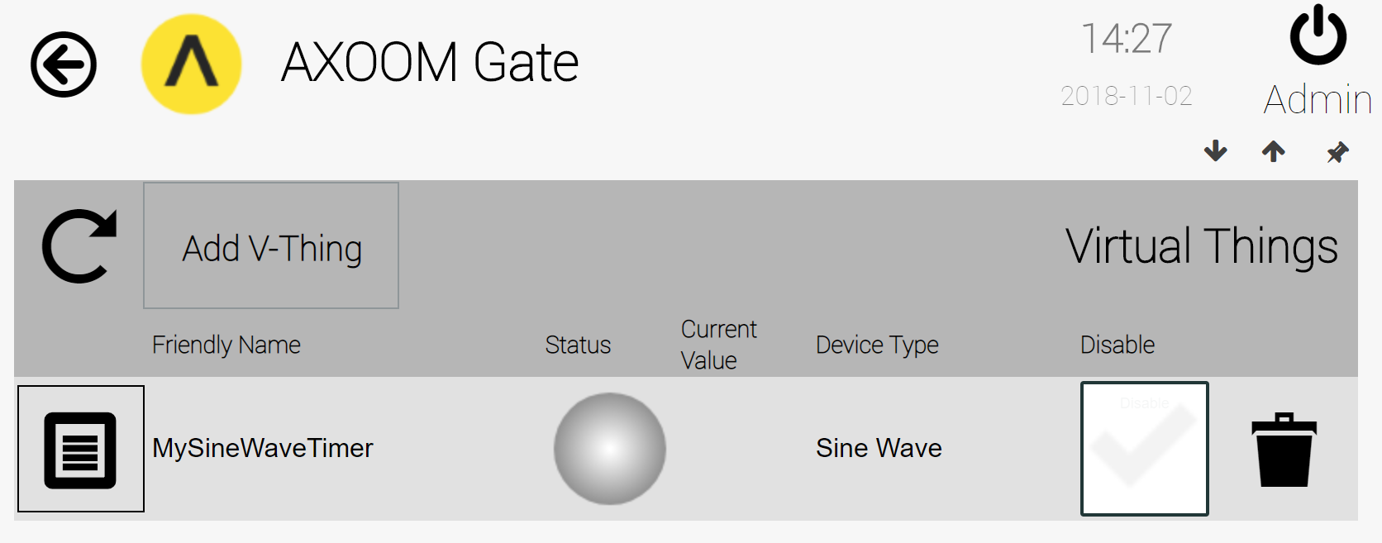
Figure 8.2. A Sine Wave virtual thing ready to be configured.
Click on the properties icon () on the left side of this row to summon a configuration page. Figure 8.3 shows the countdown configuration page, with all settings groups visible. The important settings are described in the following table:
Field Name | Description
Current Value | The current output value of the countdown timer. This value is also represented graphically in a bar chart on the lower left side of the settings page.
Trigger | The green Trigger button starts the sine wave timer.
Stop | The red Stop button stops the sine wave timer.
Tick time in ms | The time, in milliseconds, to wait between calculations.
Step | A floating-point number for incrementing the input value to the sine function. If set to zero, the value of 1 is used.
Amplitude | The range of values for the output value. Any value less than 10 results in the use of 10 as the amplitude. At this setting (with a shift value of 0), output values range from -5 to 5.
Shift | A positive value to be used as the middle of the range of output values. In other words, a value added to the output value to shift the range of output values outside the default -5 to +5. For example, 1 shift value of 100 (with an amplitude of 10) results in output values from 95 to 105.
Autostart | Whether to start this control automatically after AXOOM Gate restarts.

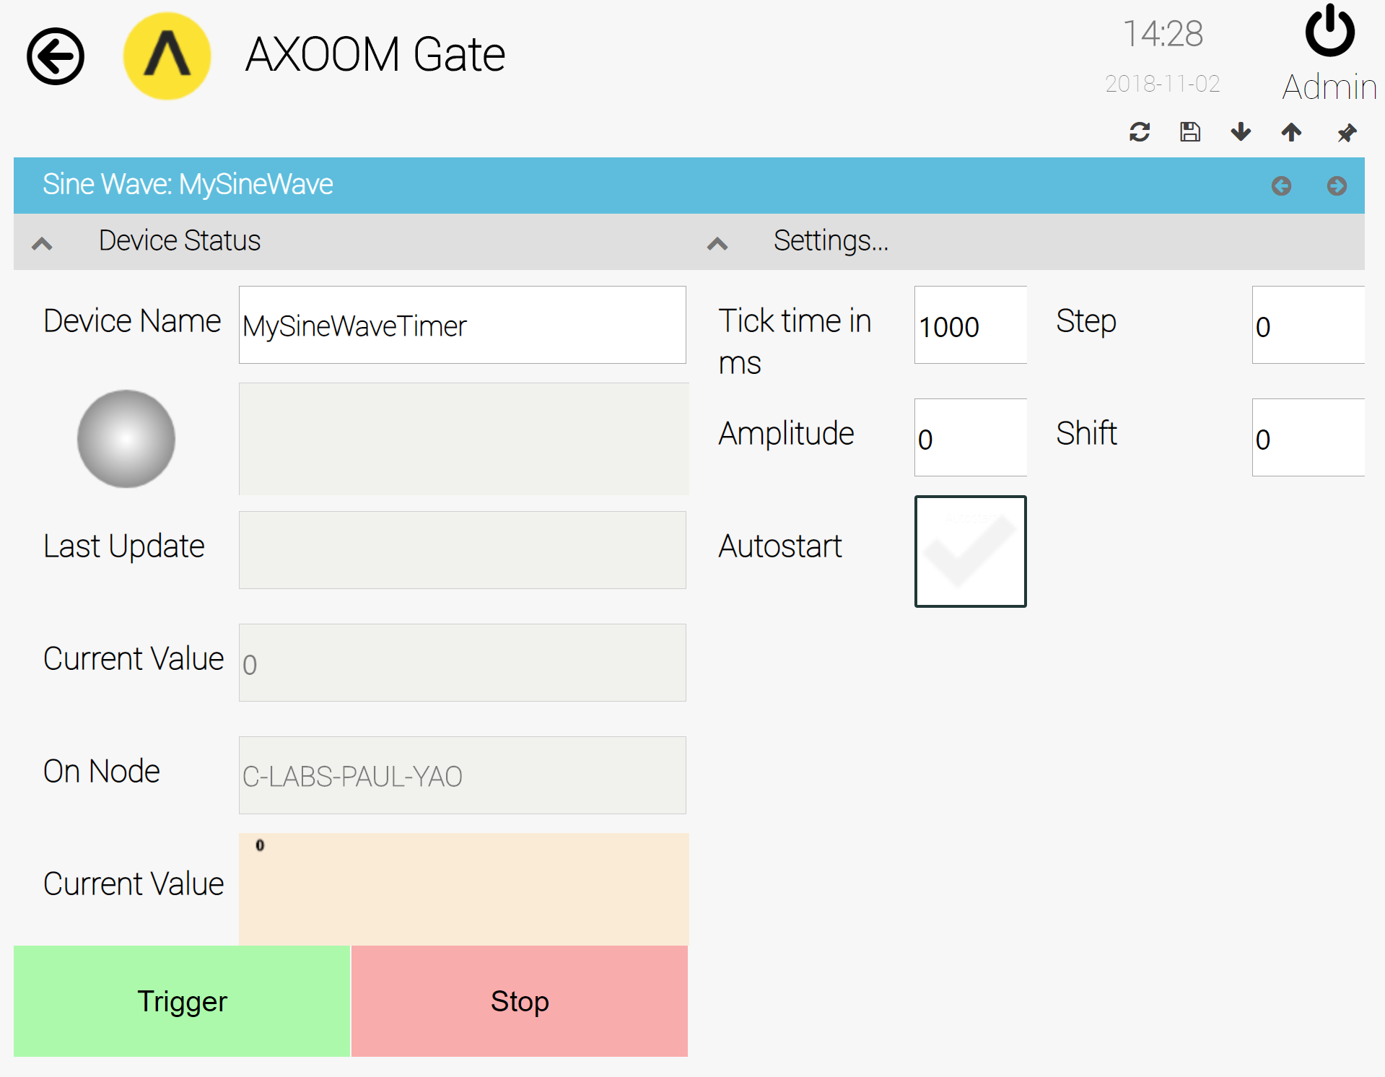
Figure 8.3. Sine Wave Timer virtual thing settings page with all settings groups visible.

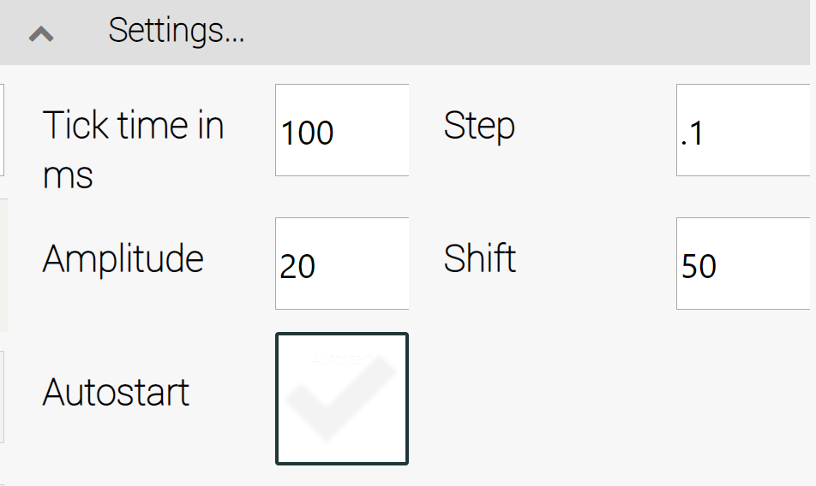
Figure 8.4. Sample settings for the Sine Wave timer.
Figure 8.4 shows sample settings for the countdown timer. With these settings, after the user clicks the Trigger button, the input values increment by .1 for each calculation, which is performed every 1/10 of a second. The output values range from a minimum of 40 and a maximum of 60, which represents an amplitude of 20 with values that have 50 as its center.

Live View of Sine Wave Timer
Figure 8.5 shows an example of the “live” view of a countdown timer in operation that appears on the dashboard of the Virtual Things plugin.

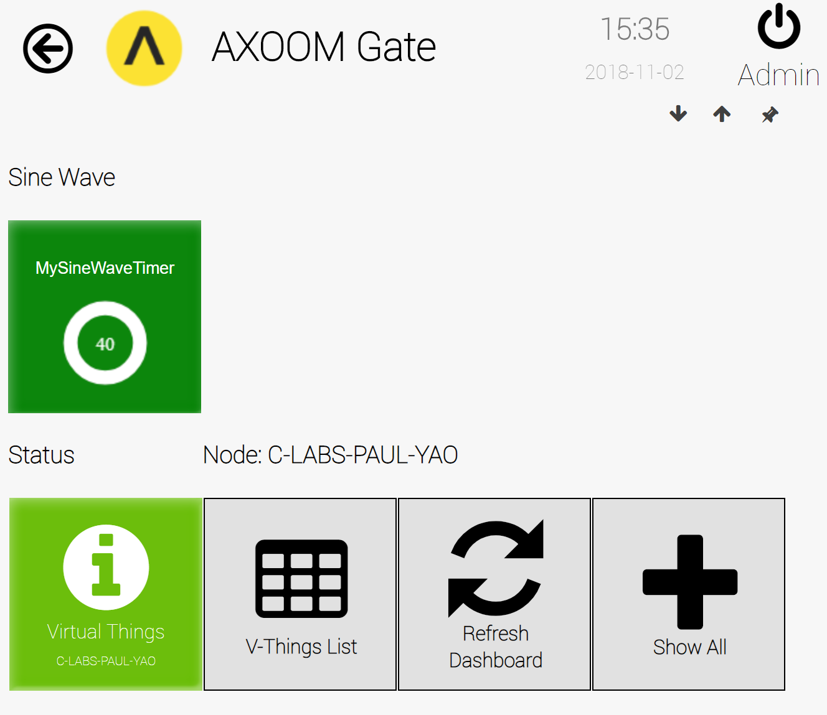
Figure 8.5. The live view of a Sine Wave timer.

Timer
A Timer is a virtual device that counts upward from zero at a pace specified as the Loop Time property (in milliseconds).
Two related virtual devices are the Countdown Timer, which counts from specified start value down to zero, and the Sine Wave, which generates a set of values related to the trigonometric sine function.

Creating a Timer
To create a timer, click on the Add V-Thing button in the Virtual Things table (see Figure 9.1), then select a device type of "Timer".
Figure 9.1. The Virtual Things table.

Configuring a Timer
After creating a timer, it needs to be configured. This chapter walks through the configuring of a timer named MyTimer. Figure 9.2 shows the timer in the Virtual Things list.
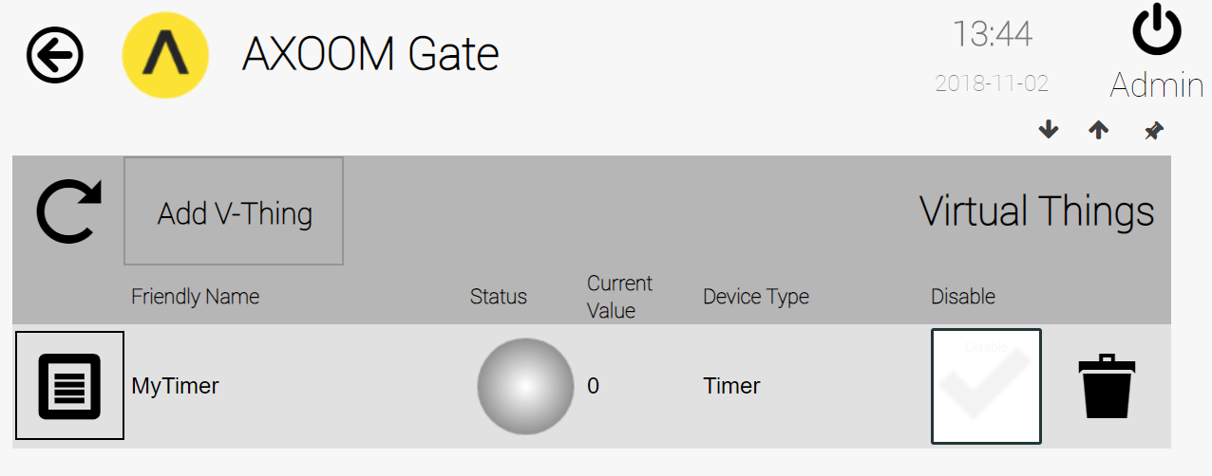
Figure 9.2. The timer virtual thing ready to be configured.
Click on the properties icon () on the left side of this row to summon a configuration page. Figure 9.3 shows the timer configuration page, with all settings groups visible. The important settings are described in the following table:
Field Name | Description
Current Value | The current output value of the timer.
Ms to Trigger | The time, in milliseconds, to delay before the first wait loop. Must be a non-zero value.
Loop Time | The time, in milliseconds, for each wait loop. Must be a non-zero value.
Auto Start | Whether to start this control automatically after AXOOM Gate restarts.
Is Started | A read-only checkbox that displays when the timer is running.
Start | The green Start button starts the timer.
Stop | The red Stop button pauses the timer.

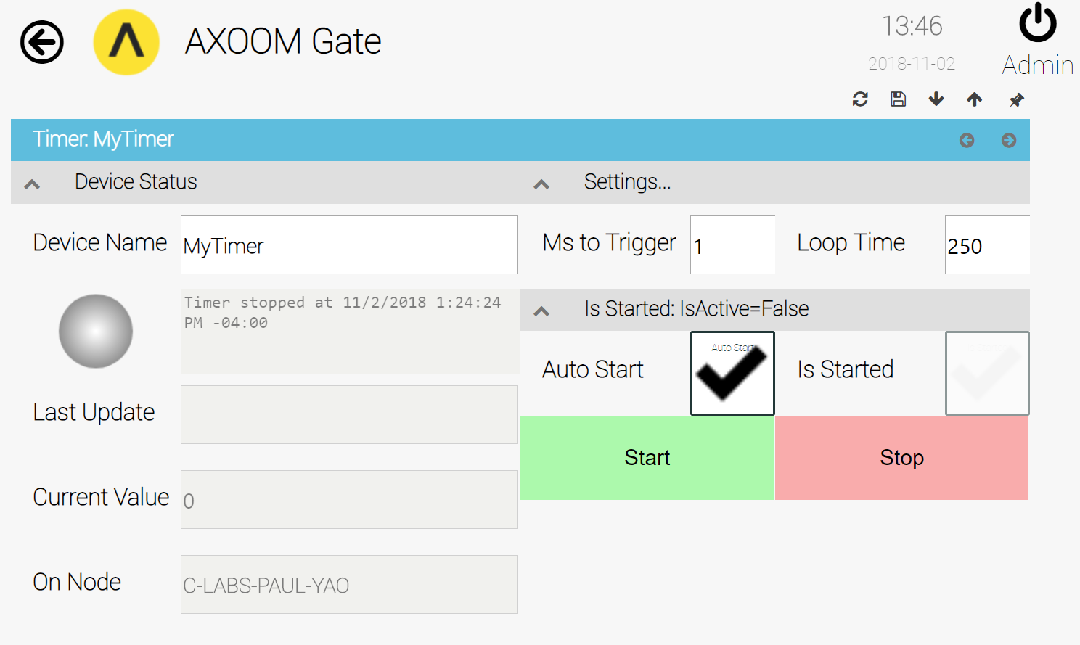
Figure 9.3. Timer virtual thing settings page with all settings groups visible.

Figure 9.4 shows sample settings for the timer. With these settings, after the user clicks the Start button, there is a wait of 2.5 seconds before the timer loop starts and values are incremented. There is a wait of 250 milliseconds between each incrementing of the counter.

The Live View of a Timer
Figure 9.5 shows an example of the "live" view of a countdown timer in operation that appears on the dashboard of the Virtual Things plugin.
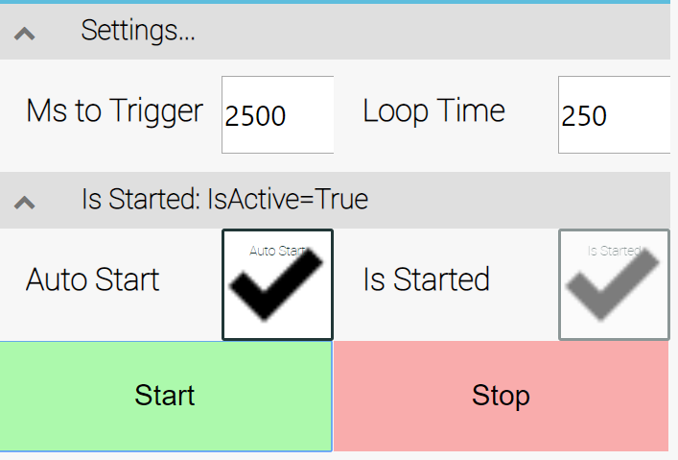
Figure 9.4. Sample settings for a timer.

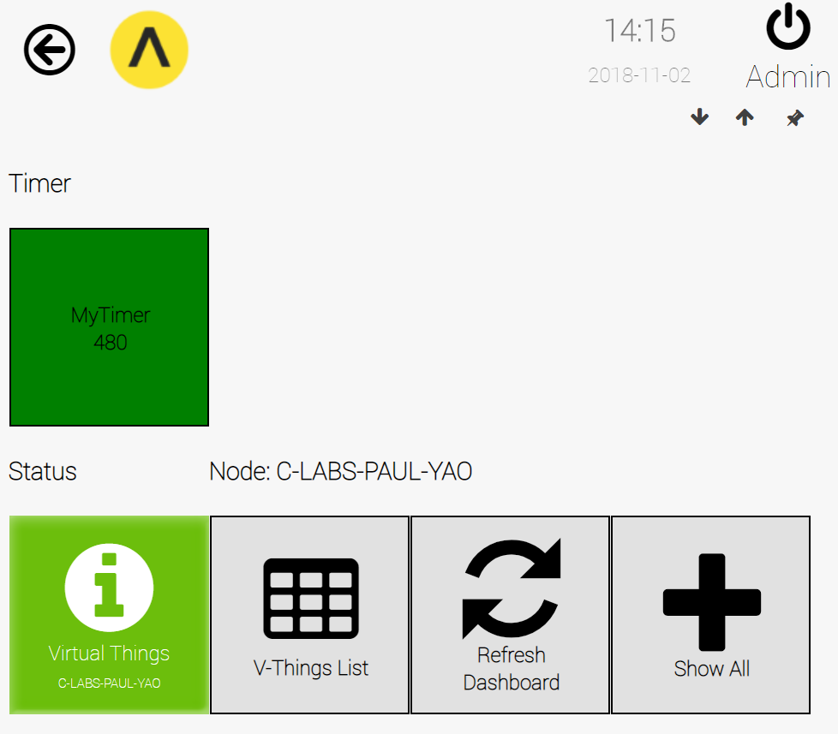
Figure 9.5. The live view of a timer.

Virtual Sensor
A Virtual Sensor is a virtual device that provides various data visualization elements for a numeric value created by any object created by any plugin.

Creating a Virtual Sensor
To create a Virtual Sensor, click on the Add V-Thing button in the Virtual Things table (see Figure 10.1), then select a device type of "Virtual Sensor".
Figure 10.1. The Virtual Things table.

Configuring a Virtual Sensor
After creating a Virtual Sensor, you need to configure it. This chapter walks through the configuring of a Virtual Sensor named MyVirtualSensor. Figure 10.2 shows the Virtual Sensor in the Virtual Things list.
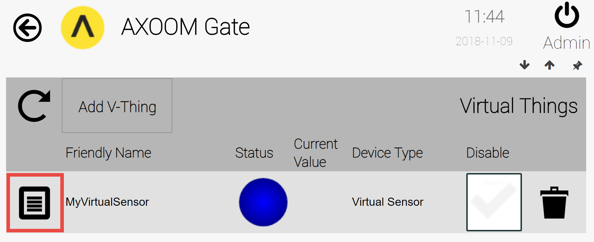
Figure 10.2. A Virtual Sensor ready to be configured.
Click on the properties icon () on the left side of this row to access the Virtual Sensor configuration page. When you access the Virtual Sensor settings, you see that the settings fields are hidden (see Figure 10.3) as the Virtual Sensor opens to show its various output display elements.
To access the Virtual Sensor configuration fields, click in the highlighted area that contains the title "Sensor Report." There are four groups of configuration settings: (1) Sensor Report, (2) Sensor Info…, (3) Sensor Settings…, and (4) Advanced Settings. By default, each group of the configuration settings is closed. Click on the corresponding title bar to open each group. Figure 10.4 shows the Virtual Sensor configuration page, with all settings groups visible. Discussion of each settings group is provided in the sections that follow.
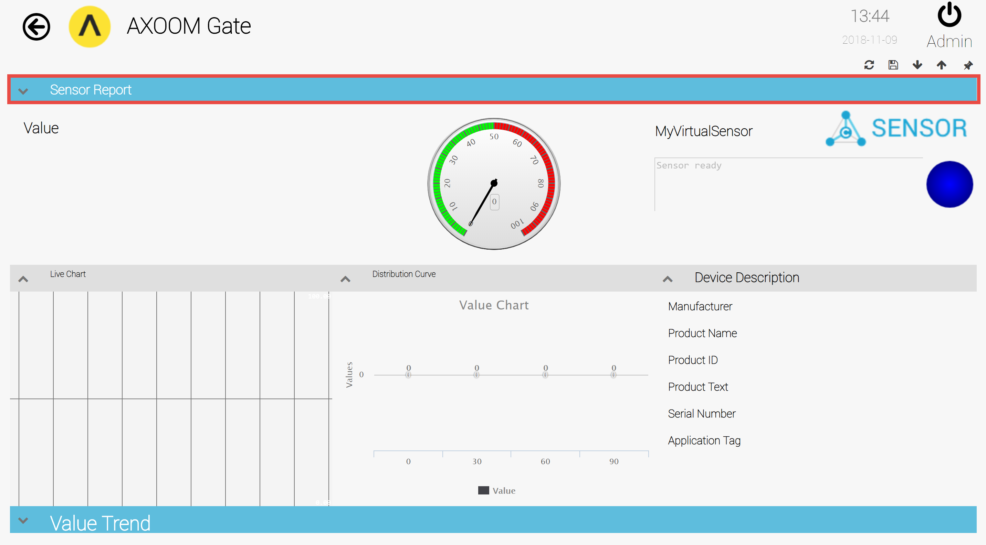
Figure 10.3 The elements of a Virtual Sensor display are, by default, open and visible.

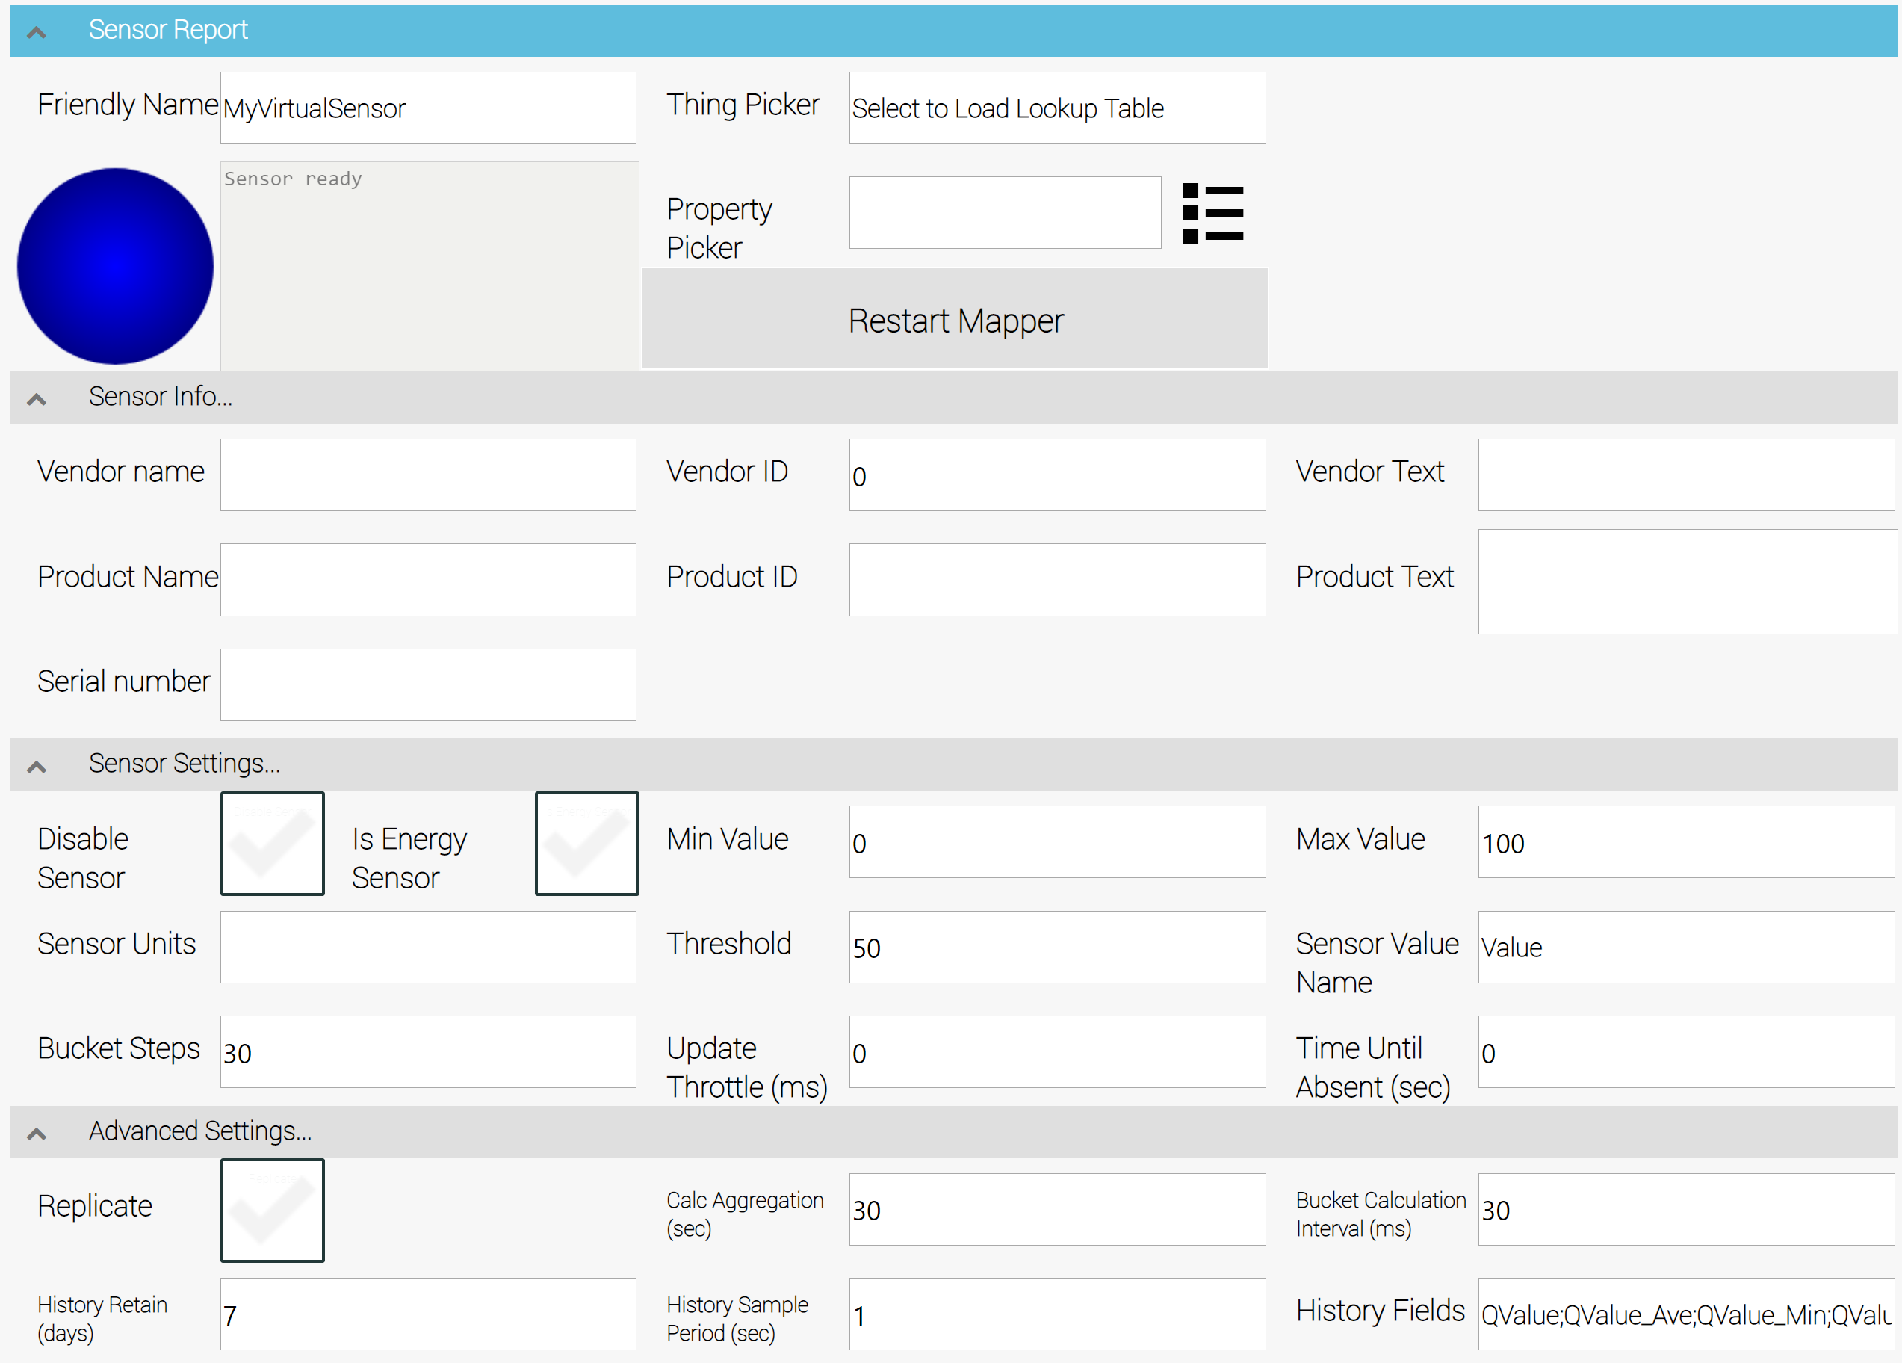
Figure 10.4 The four Virtual Sensor configuration settings groups.

The Sensor Report Configuration Settings
The first group of configuration settings is the first one to open (see Figure 10.5). It contains the basic elements for connecting the property of any object to the Virtual Sensor. (Section 10.7 provides a walkthrough of connecting a sine wave object to a Virtual Sensor.)
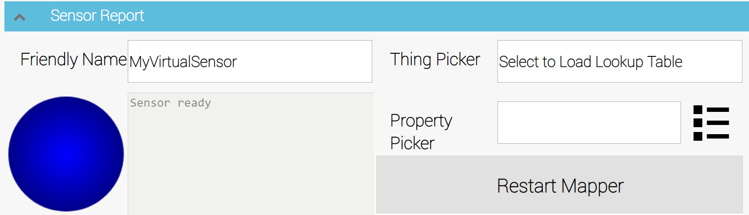
Figure 10.5. The Sensor Report Configuration Settings group.
There are six fields in this group of configurations:
- Friendly Name is a name that identifies the Virtual Sensor.
- Status Light is blue when the state is unknown, and green when the sensor is running.
- Status Text is the most recently received status message from the Virtual Sensor.
- Thing Picker is an object selection field for connecting any AXOOM Gate object to a Virtual Sensor.
- Property Picker is a property selector that lets you select the specific property to use as input to the Virtual Sensor. It must be a numeric field. When in doubt, the field named "Value" is a good place to start a search for the right property.
- Restart Mapper button is a button for restarting the Virtual Sensor after having made any change to the Thing Picker field or the Property Picker field.

The Sensor Info… Configuration Settings
The second set of configuration settings (see Figure 10.6) are a collection of input fields for capturing product details of a specific sensor.
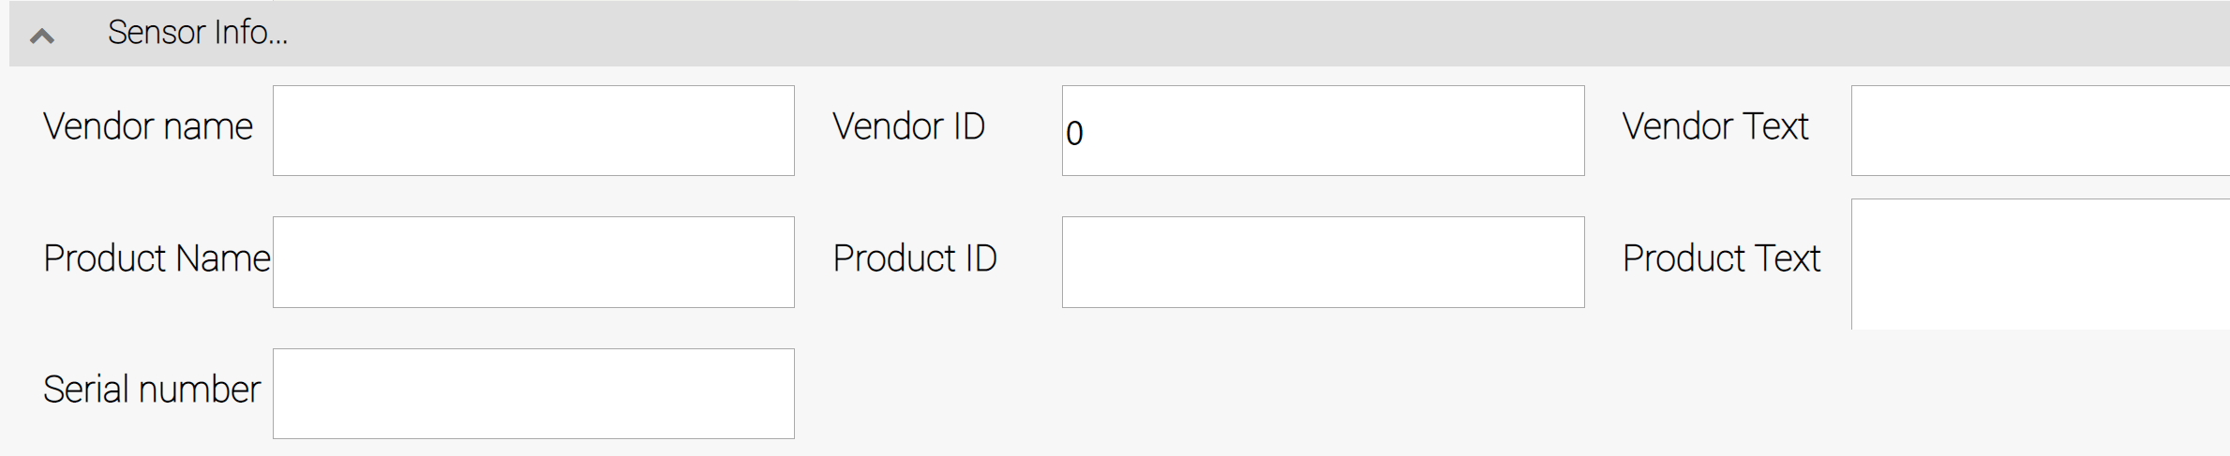
Figure 10.6. The Sensor Info… Configuration Settings group.
These product details are displayed in the output portion of the Virtual Sensor. In addition, they provide a starting point for some interesting future scenarios. One example is automating an inventory of connected sensors. This, of course, assumes that the fields have been filled in with correct values. Another scenario involves automating the configuration of sensors based on the values provided in the product sensor information fields. Also, the presence of these fields provides a way to store sensor data in any situation where the identification of sensor information can be automated, such as can be partially accomplished using the current USB specifications.
As shown below, the sensor product details can be divided into two sets: information about the product vendor, and information about the product itself.
- Vendor information fields:
  - Vendor name – The company that provides the product.
  - Vendor ID – A unique vendor code.
  - Vendor Text – Human readable information about the vendor.
- Product information fields:
  - Product name – The sensor product name.
  - Serial Number – The unique identifier for the product that is installed.
  - Product ID – A code that, when paired with the Vendor ID, provides an unambiguous way to identify a specific sensor product.
  - Product Text – Human readable information about the product.

The Sensor Settings… Configuration Settings
The third set of Virtual Sensor configuration settings provide a mix of fields that allow for the fine-tuning of the handling of the incoming data stream.
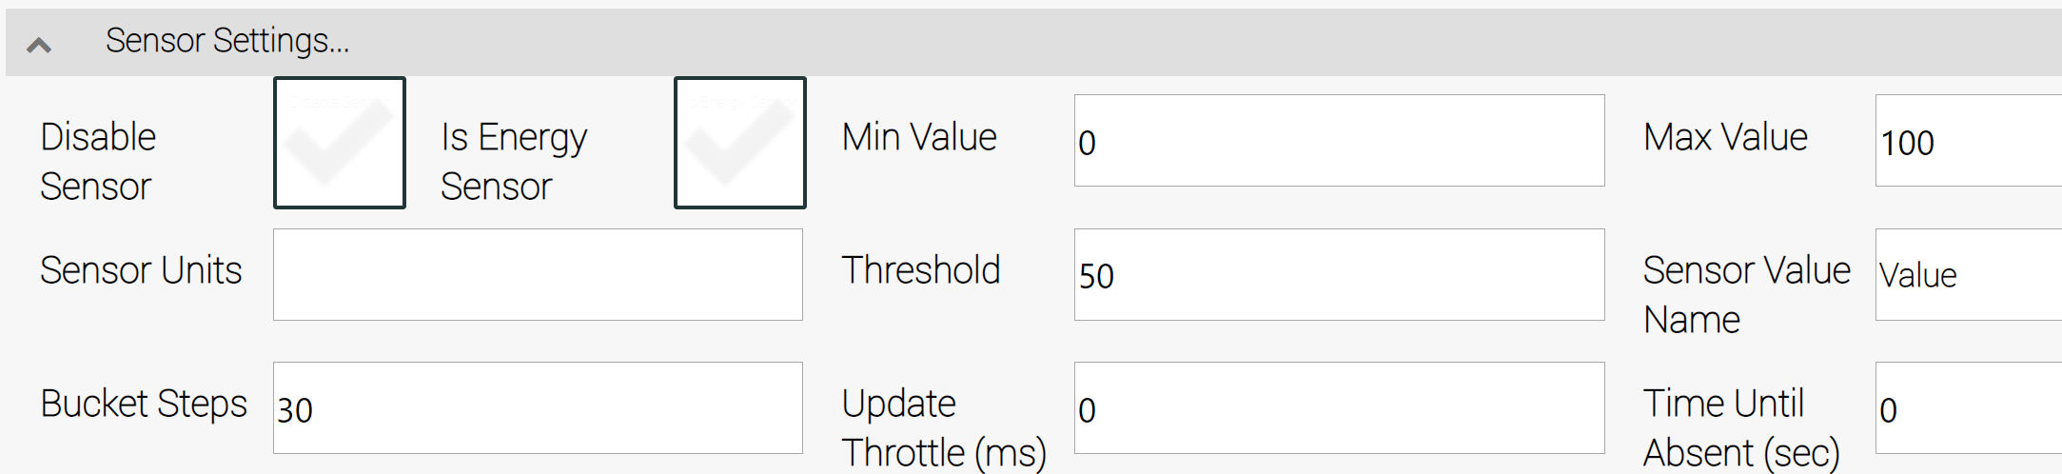
Figure 10.7. The Sensor Settings… Configuration Settings group.

- Disable Sensor allows the user to disconnect the incoming data stream from the Virtual Sensor.
- Is Energy Sensor is a setting that identifies data streams that for energy use in Watts. Changes to such fields can be used to centrally track energy usage.
- Sensor Units is the human-readable name for the measure of value of the incoming data stream.
- Bucket Steps is used in the "Distribution Curve" portion of the Virtual Sensor. This value is used with two other values, Min Value and Max Value, to set the range of values for each "bucket".
- Min Value is the minimum expected value. The Virtual Sensor uses this to scale the graphical output that is automatically created.
- Threshold is used by the gauge control as the boundary between the green and red portions of the output scale.
- Update Throttle (ms) sets the maximum rate, in milliseconds, that changes to values are reported. When set to zero, the throttle mechanism is disabled.
- Max Value is the maximum expected value. Like Min Value, this is used to scale graphical output.
- Sensor Value Name is the human readable text to identify the meaning of the updated value as displayed in the Virtual Sensor output area.
- Time Until Absent (sec) is the timeout for marking setting the status of the input stream as unknown. When set to zero, this feature is not used.

The Advanced Settings… Configuration Settings

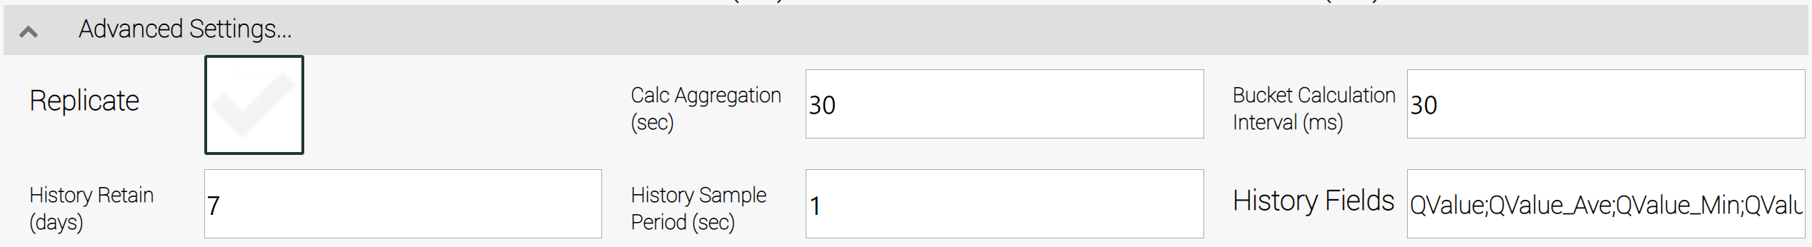
Figure 10.8. The Sensor Report Configuration Settings group.

- Replicate is a checkbox that marks a Virtual Sensor as being global, so that changes are sent to every node in the mesh. This can have performance implications, so take care to use it only when necessary.
- History Retain (days) is the number of days' worth of data to store. Care should be taken when setting this field because it can result in significant disk usage.
- Calc Aggregation defines the frequency of updating aggregate totals for average (QValue_Ave), the minimum (QValue_Min), and the maximum (QValue_Min) values.
- History Sample Period (sec) is the frequency of capturing and storing values, in seconds.
- Bucket Calculation Interval (ms) is the frequency of sampling data for use in the "Distribution Curve" chart.
- History Fields is a list of fields to store, delimited by semi-colons. The default value is QValue;QValue_Ave;QValue_Min;QValue_Max. This represents:
  - QValue – the value being tracked.
  - QValue_Ave – the average value for a sample period.
  - QValue_Min – the minimum value for a sample period.
  - QValue_Max – the maximum value for a sample period.

Walkthrough of Setting Up a Virtual Sensor
This section describes setting up a Virtual Sensor as a wrapper around a Sine Wave virtual thing, to enable the visualization of values generated by the Sine Wave virtual thing.

Create a Sine Wave Virtual Thing
Create a Sine Wave virtual thing by following the instructions in the Sine Wave chapter. Modify the settings to match the settings page in Figure 10.9.
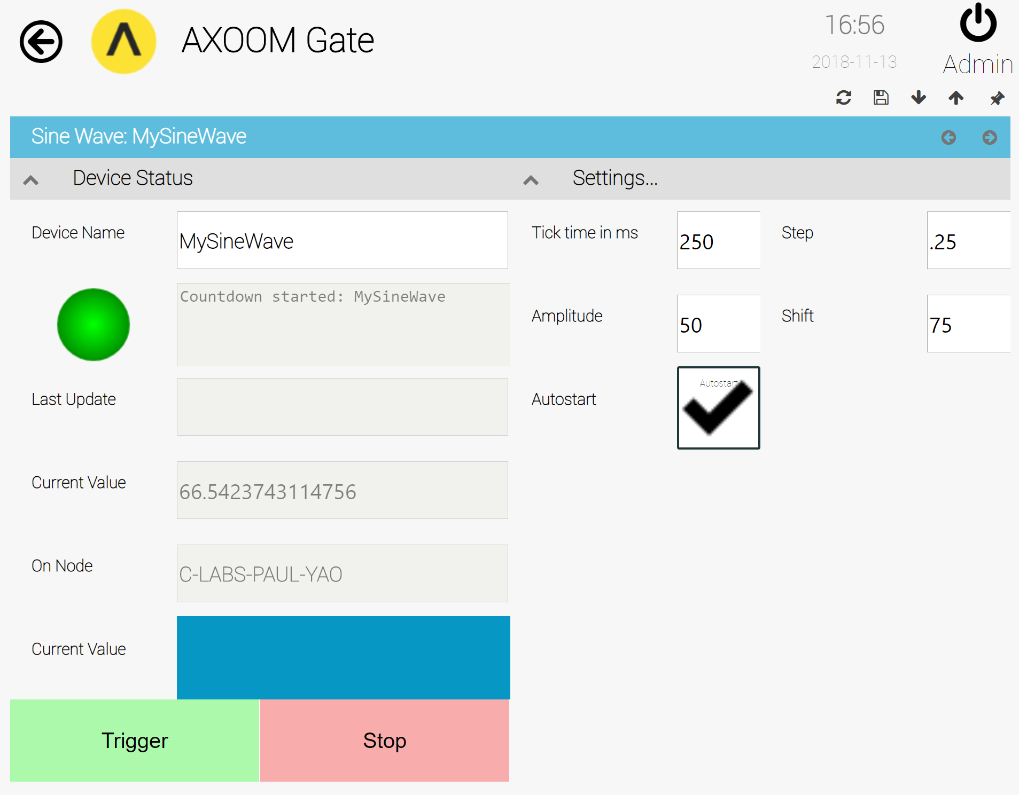
Figure 10.9 Settings for a Sine Wave virtual thing to be used in the Virtual Sensor.
These settings create a Sine Wave object that generates a new data point every ¼ or a second. To make sense of the sine wave settings, it helps to start on the output end of things. For that, there are two interesting settings: Amplitude and Shift. When the Amplitude is set to 50, you will see output values in the range -25 to +25. By setting the Shift value to 75, we modify the output values so that the new range is (-25 + 75) to (+25 + 75) or +50 to +100.
On the input side of things, there are also two values of interest: Tick Time and Step. Tick Time is the frequency for generating new values. The Step value sets the wave length, meaning how quickly the sine wave repeats. The wave length is inversely proportional to the Step value, so that a very low value gives a very long, slow wave, and a high value gives a very short, quick wave. A value for Step of 0.25 will cycle through a complete sine wave in about 7 seconds (assuming a Tick Time of 250 ms). Setting the Step to .01 slows things down so that it takes about 3 minutes to cycle through a single wave. Setting the value to 1 creates a wave length of less than 3 seconds.

Creating a Virtual Sensor
Figure 10.10. The Virtual Things table.
Next, create a Virtual Sensor. In the Virtual Things table, click on the Add V-Thing button (see Figure 10.10), provide a friendly name such as "MyVirtualSensor", select a device type of "Virtual Sensor", then click the checkbox button to save.

Connecting the Sine Wave to a Virtual Sensor
Figure 10.11. A Virtual Sensor ready to be configured.
The connection from the Virtual Sensor to the Sine Wave is handled in the settings of the Virtual Sensor. After creating the Virtual Sensor, the Virtual Things table appears as in Figure 10.11. Click on the settings icon () on the left side of the row to access Virtual Sensor settings.
The page that appears shows the output display area (see Figure 10.12) for Virtual Sensors. To access the first of the four groups of settings, click in the title bar that has the text "Sensor Report" (highlighted in Figure 10.12).
Figure 10.12. Virtual Sensor output display areas.
The first group of settings fields (see Figure 10.13) includes these two input fields: Thing Picker and Property Picker. Of all available settings, these two are the most important because they identify the data values to be used as input to the Virtual Sensor.
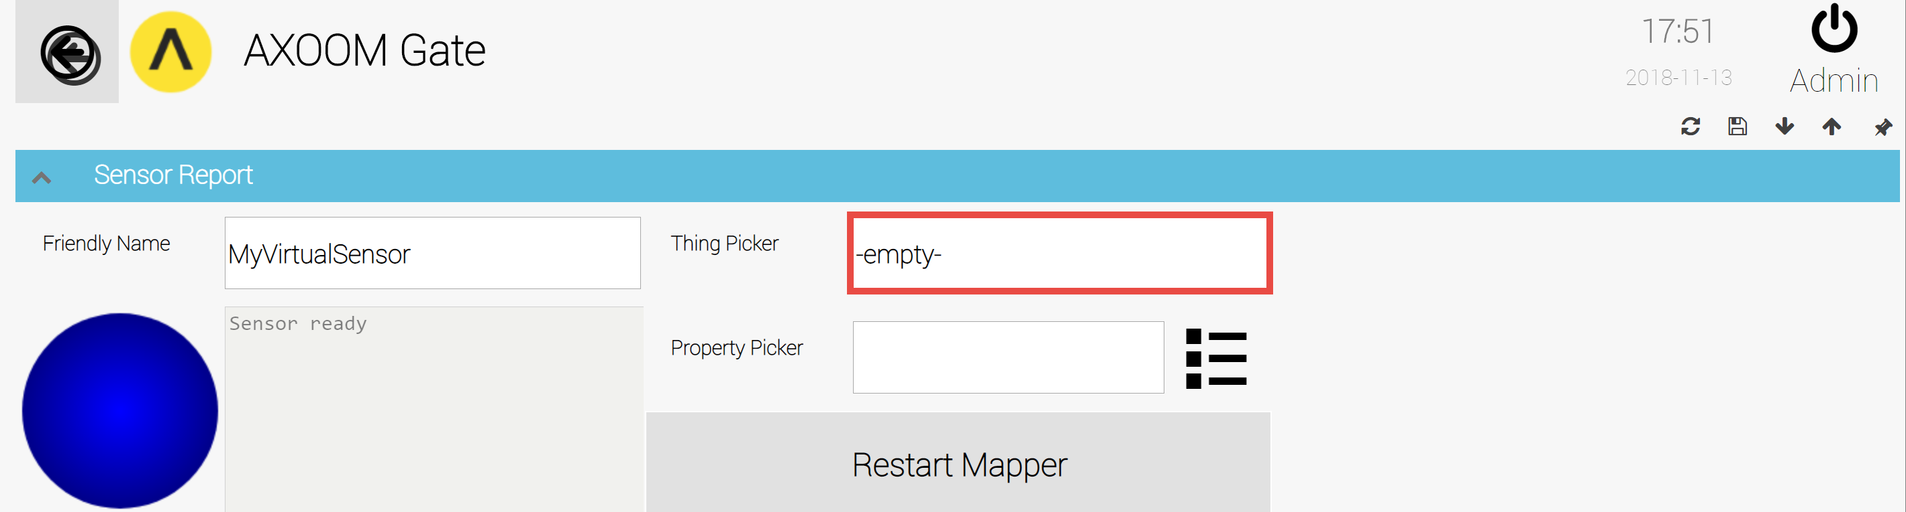
Figure 10.13. Thing Picker and Property Picker in Virtual Sensor settings.
Use the Thing Picker field to select the "thing" (or object) of interest. Click in the highlighted area in Figure 10.13. When the Thing Picker table has not been loaded into memory, you see a request that says, "Select to Load Lookup Table" (see Figure 10.14). If that happens, click the SELECT option which loads the lookup table and closes the Thing Picker. Click inside the Thing Picker a second time to see the list of things (right column) and the engines (or plugins) that created them (see Figure 10.15).
The list of engines and things scroll up and down, allowing you to select any existing "thing" that exists. Figure 10.16 shows the Thing Picker with MySineWave, ready to be selected. Click the SELECT option.
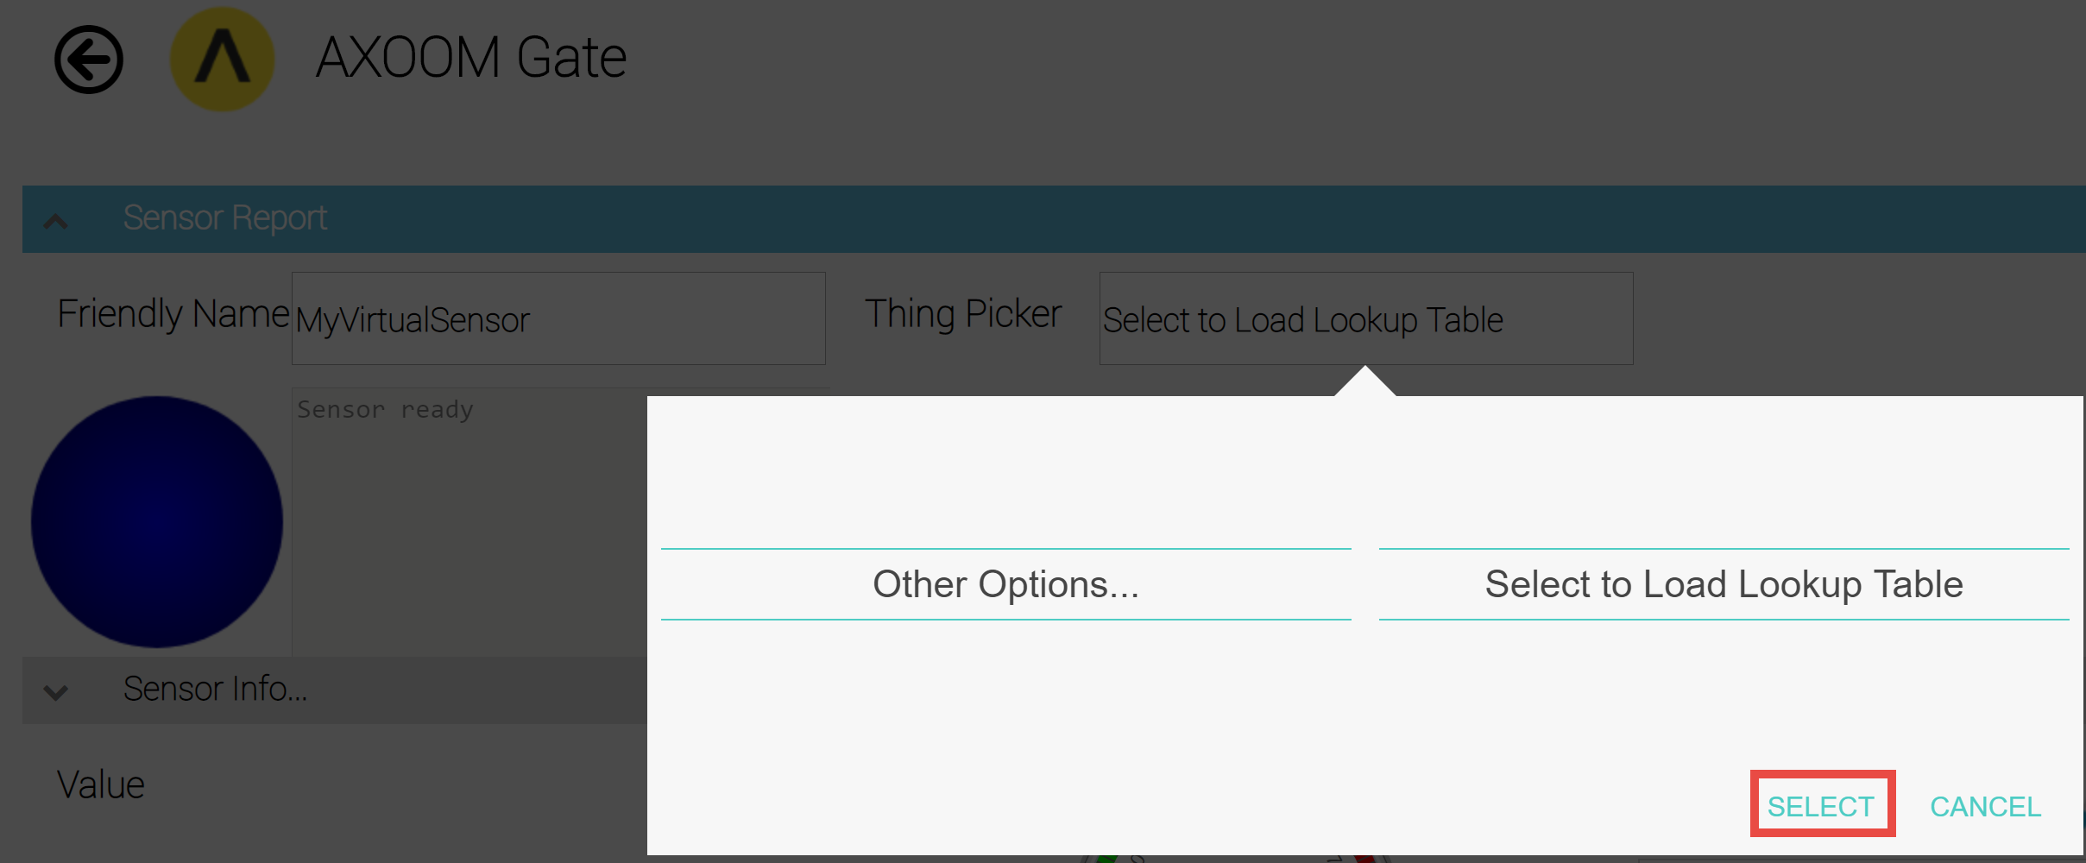
Figure 10.14. Thing Picker when lookup table is not loaded into memory.
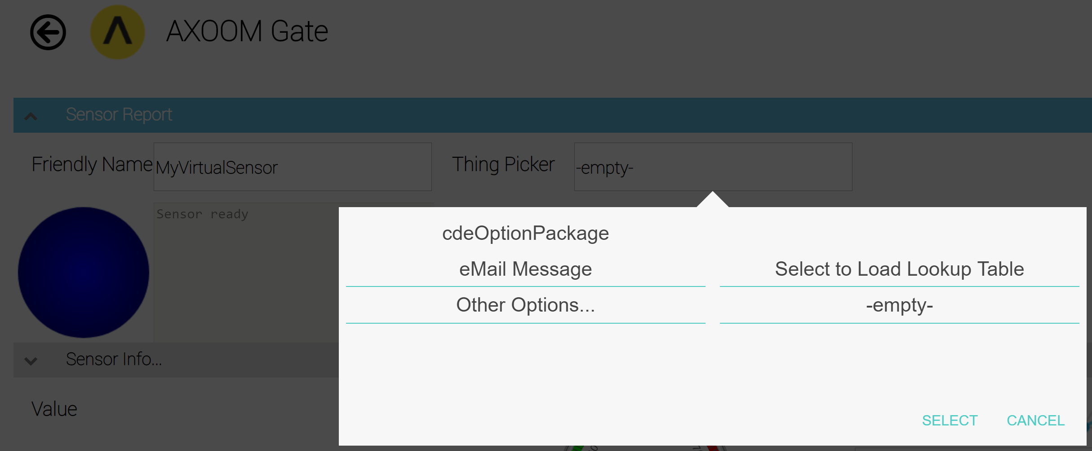
Figure 10.15. Thing Picker when lookup table has been loaded into memory.

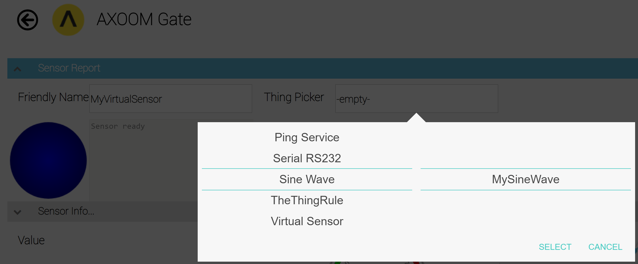
Figure 10.16. Thing Picker showing MySineWave, the input source.
Once you have selected the "thing" to use, the next step is to select the specific property to use.
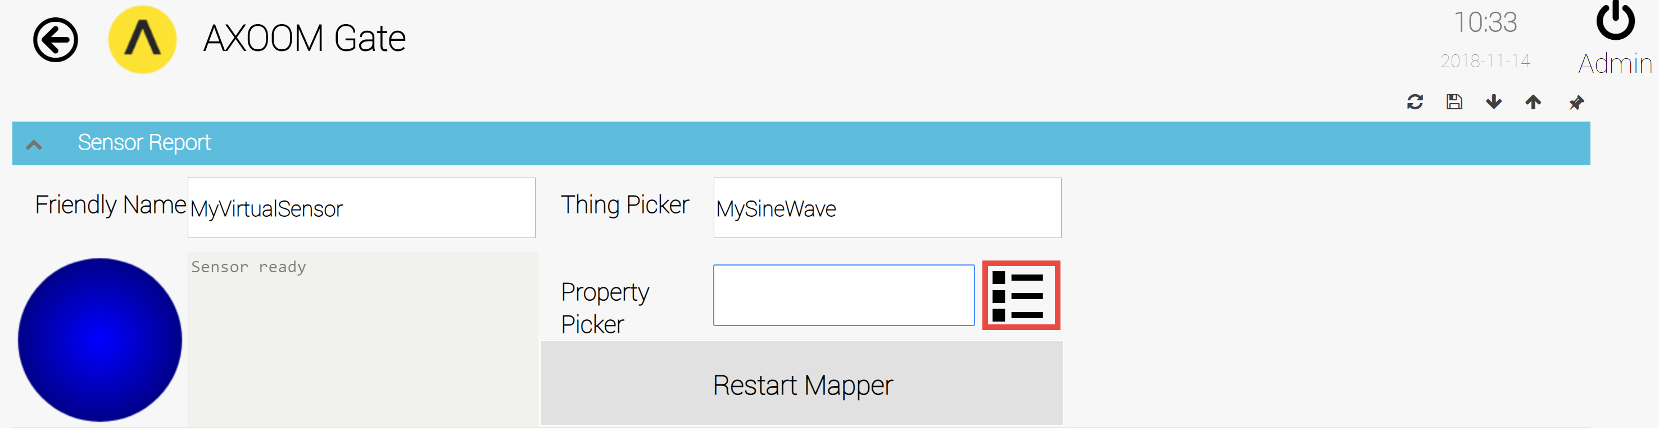
Figure 10.17. Open the Property Picker by clicking in the highlighted area.
Figure 10.17 shows that MySineWave is the currently selected "thing". Click in the highlighted area to summon the select the property to use.
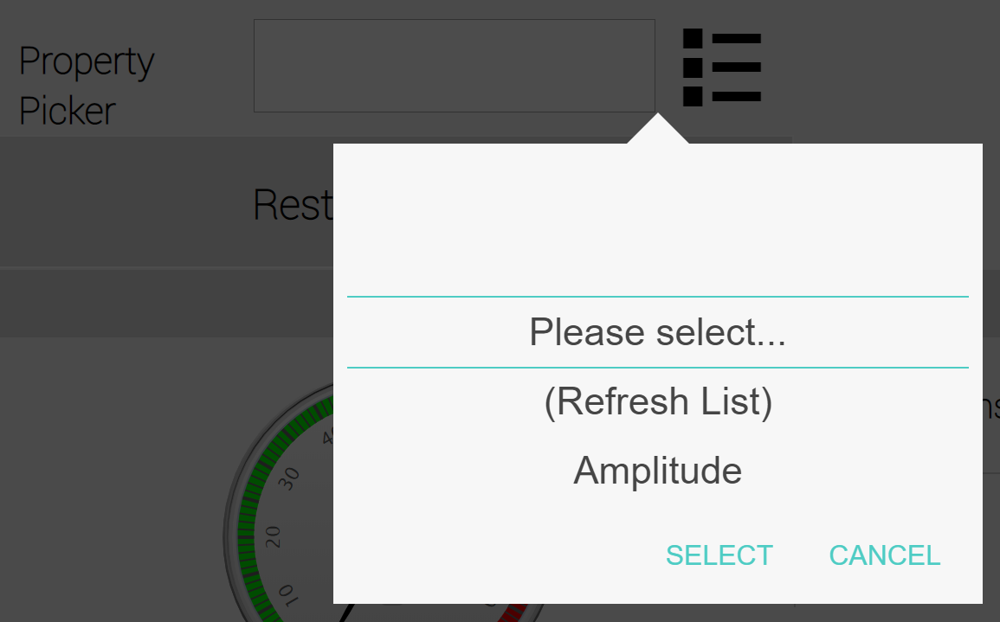
Figure 10.18. The Property Picker when first opened.
Figure 10.18 shows the Property Picker when first opened. Figure 10.19 shows the property named "Value" ready to be selected for use. When ready, click the SELECT option.
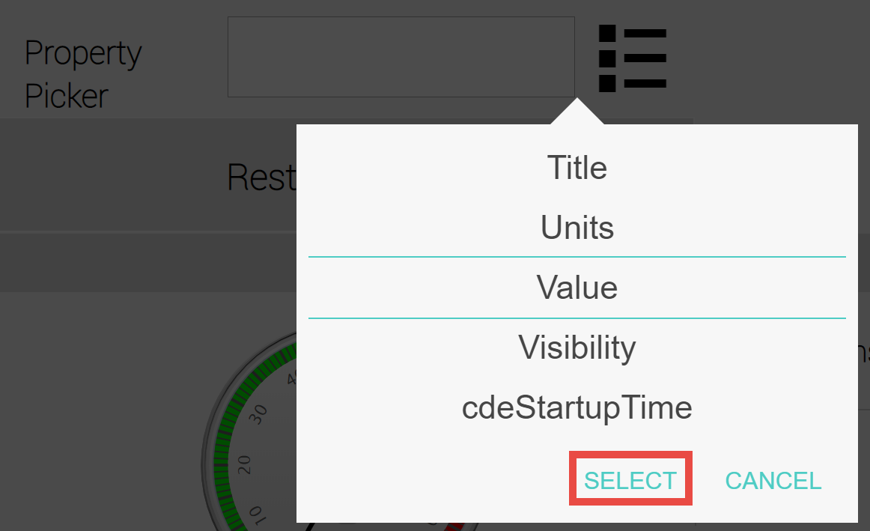
Figure 10.19. The Property Picker with the property "Value" ready to be selected.
The display portion of the Virtual Sensor comes to life when data is available. Figure 10.20 shows the result of receiving input from the Sine Wave virtual thing, showing both the current value as well as a chart of historic values.
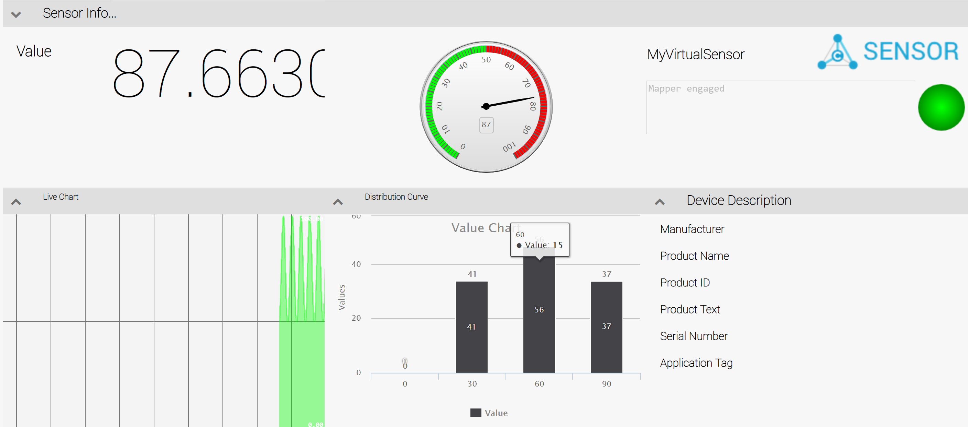
Figure 10.20. Virtual Sensor showing the output from values received from the Sine Wave virtual thing.

Virtual State Sensor
A Virtual State Sensor is a virtual thing that allows for filtering and preprocessing of a property value from any object created by any plugin.

Creating a Virtual State Sensor
To create a Virtual State Sensor, click on the Add V-Thing button in the Virtual Things table (see Figure 11.1), then select a device type of "Virtual State Sensor".
Figure 11.1. The Virtual Things table.

Configuring a Virtual State Sensor
After creating a Virtual State Sensor, you need to configure it. This chapter walks through the configuring of a Virtual State Sensor named MyStateSensor. Figure 11.2 shows the newly created Virtual State Sensor in the Virtual Things list.
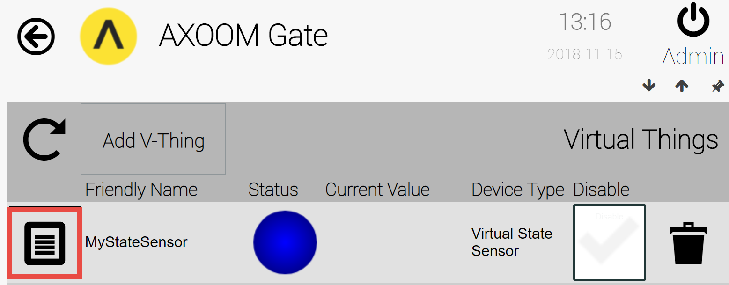
Figure 11.2. A Virtual State Sensor ready to be configured.
Click on the properties icon () on the left side of this row to access the Virtual State Sensor configuration page. Figure 11.3 shows the configuration page, with all of the groups opened. There are five different groups of fields. Details for each group appears in the sections which follow.
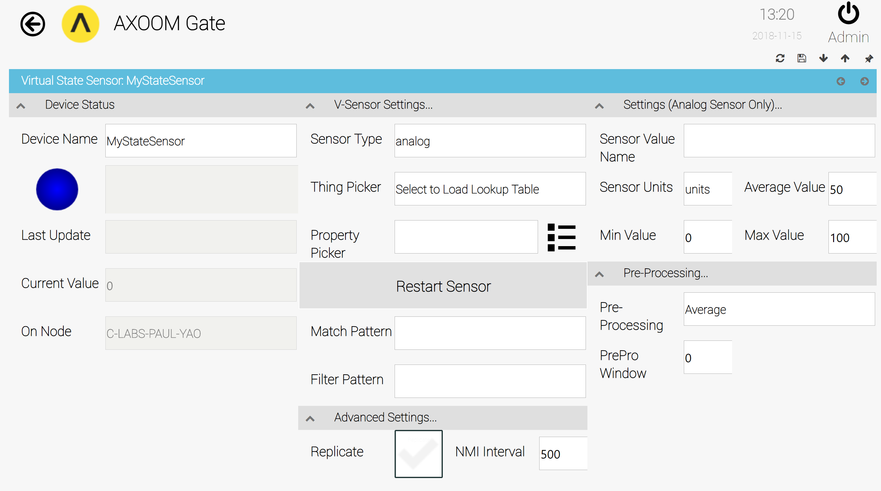
Figure 11.3. The Virtual State Sensor configuration fields.

Device Status Settings
The Device Status group (see Figure 11.4) provides basic plug details, including the following:
- Device Name – the “Friendly Name.” You can edit this value any time.
- Status light – The color is based on the standard set of color values that AXOOM Gate uses.
- Status text – Details about the current connection when connected; details about connection errors when not connected.
- Last Update – not in use.
- Current Value – The value that is being output by the Virtual State Sensor.
- On Node – The name of the node where the Virtual Things plugin is running.

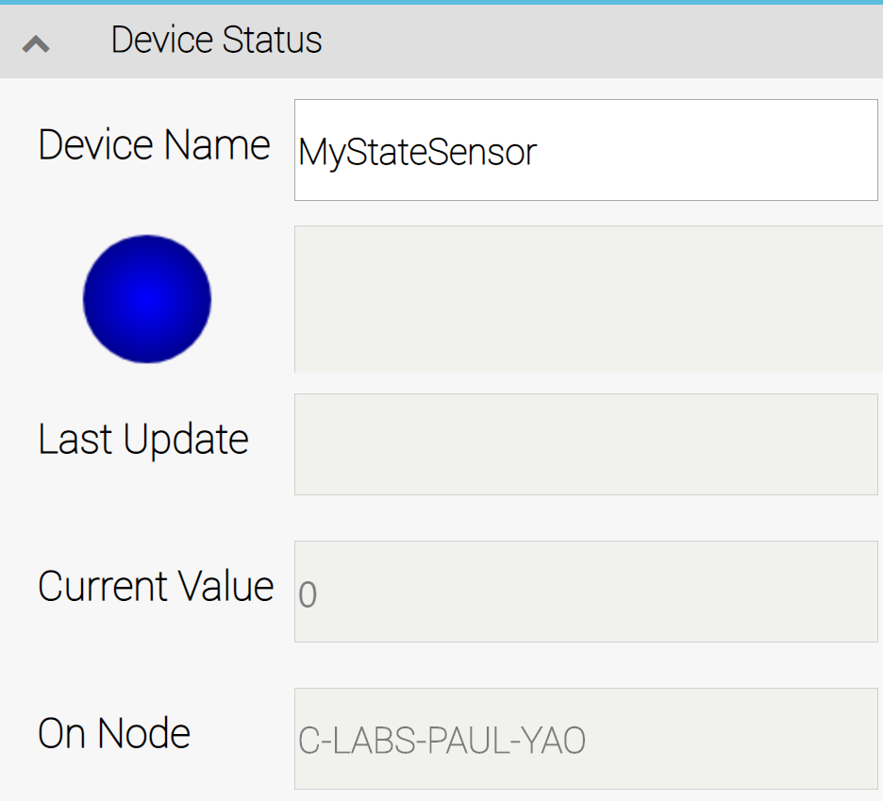
Figure 11.4. The Device Status group of settings.

V-Sensor Settings…
This group of settings provides the key definitions for the Virtual State Sensor. When you create a new Virtual State Sensor, you are probably going to start by filling in the first three fields in this group, because every other field relies on what is chosen here.
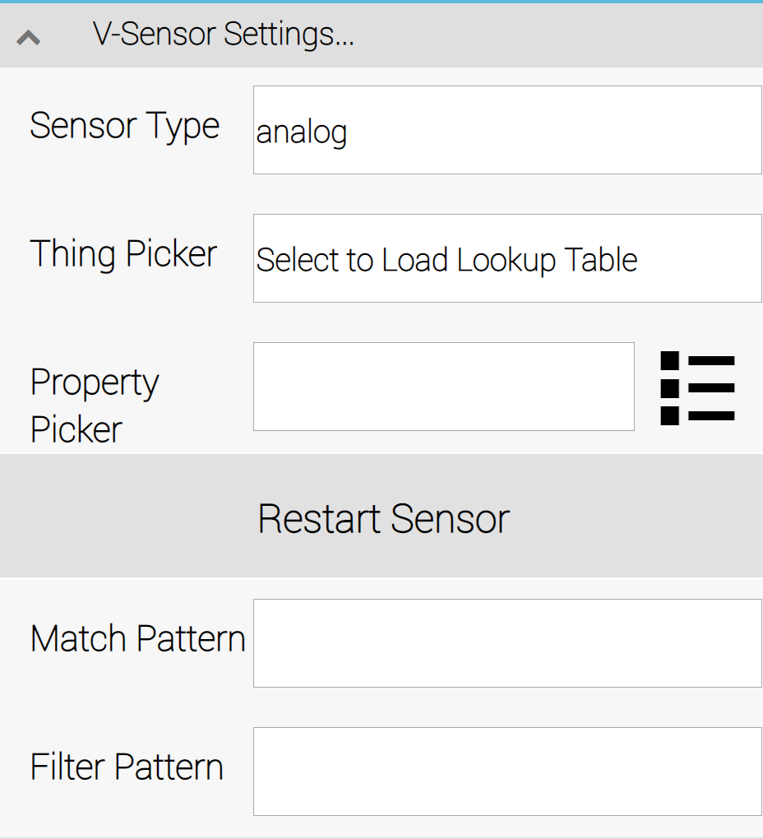
Figure 11.5. The V-Sensor Settings configuration fields.
The Sensor Type field can be one of three values: (a) analog, (b) binary, or (c) state. Select analog when the input consists of a numeric value. Select binary when the result is one of two values, either 1 or 0, true or false. Finally, select state when the input is a StatusLevel field from a "thing". The defined status levels, along with the default color associated with each level, are as follows:
- 0=Not Running (gray)
- 1=OK (green)
- 2=warning (yellow)
- 3=Failure (red)
- 4=Ramp Up (blue)
- 5=Engineering (brown)
- 6=Shutdown (purple)
- 7=Unknown/not visible (black)
Use the Thing Picker field to select the object (or "thing") that will serve as the input source. You are able to pick any existing AXOOM Gate object.
Once you have selected the object you wish to use, the Property Picker field can be used to identify the specific field to use for input.
Use the Restart Sensor button after you have made changes and want to re-start the Virtual State Sensor.
The Match Pattern field and the Filter Pattern fields are for regular expressions. The Filter Pattern field allows you to parse complex strings, eliminating extraneous characters and leaving a result that meets your own requirements. For example, here is a filter pattern that can be used to retrieve a numeric value and truncate the output to two decimal places:
[0-9]*\.[0-9]{0,2}
In the example that appears later in this chapter, we use this regular expression to modify the output of a Sine Wave virtual thing.
The Match Pattern field accepts a regular expression and uses it to determine whether the expression matches the incoming data. On a match, the return value is 1, otherwise the return value is zero. You can use this with a Boolean sensor (where the Sensor Type field set to binary) to generate the required binary output.

Advanced Settings…
The Advanced Settings group (see Figure 11.6) has two fields. Use the Replicate field (set to checked) to indicate when a Virtual State Sensor field should be treated as global to the entire mesh. When this value is set, all changes to the value are broadcast to all nodes in the mesh.
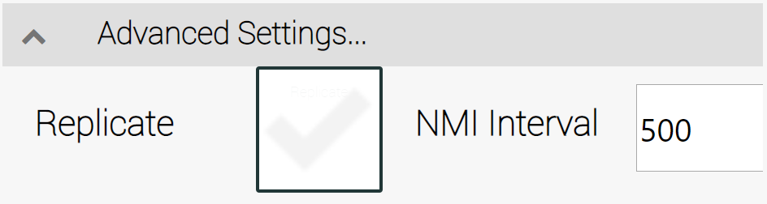
Figure 11.6. The Advanced Settings fields.
The NMI Interval field controls throttling of property change events. The number in the field is the maximum rate, in milliseconds, that value change events are generated. This throttling applies to all properties in the Virtual State Sensor, not just the ones explicitly defined in the Property Picker.

Settings (Analog Sensor Only)
The Settings group provides a set of fields for defining various useful attributes of an output stream, which can help automate the creation of a user-interface for the sensor, as well as the generation of reports. There are two string (Sensor Value Name and Sensor Units) and three integer values (Min Value, Average Value, and Max Value).
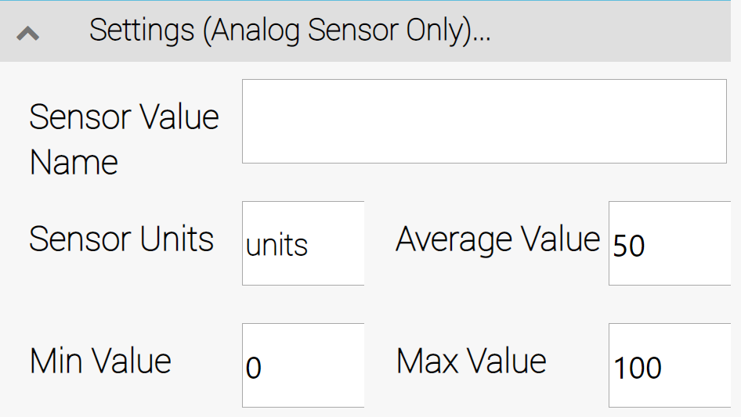
Figure 11.7. The Settings (Analog Sensor Only) fields.

Pre-Processing
The Pre-Processing group defines how the input property gets pre-processed by the Virtual State Sensor. The Pre-Processing field provides four choices: Average, Max Value, Min Value, and Raw Value.
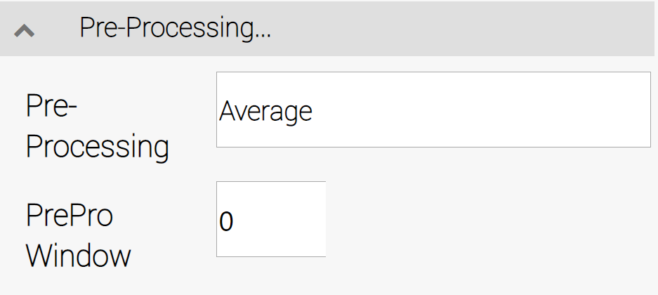
Figure 11.8. The Pre-Processing setting fields.
The second field, PrePro Window, defines the window of time (in seconds) during which values are tabulated before allowing them to be generated. This would allow, for example, the generation of an average value every 10 seconds.
There are two circumstances when pre-processing is disabled: when either (1) the pre-processing time window is set to zero, or (2) the Pre-Processing field is set to Raw Value.

Data Playback
The Data Playback virtual thing enables the playback of property changes that have been captured in the log of the Mesh Sender Plugin.

Creating a Data Playback Thing
To create a Data Playback thing, click on the Add V-Thing button in the Virtual Things table (see Figure 12.1), then select a device type of "Data Playback".
Figure 12.1. The Virtual Things table.

Configuring a Data Playback Thing
After creating a Data Playback thing, it needs to be configured. This chapter walks through the configuring of a Data Playback thing named MyDataPlayback. Figure 12.2 shows this in the Virtual Things list.
Figure 12.2. The timer virtual thing ready to be configured.
Click on the properties icon () on the left side of this row to summon a configuration page. Figure 12.3 shows the timer configuration page, with all settings groups visible. The important settings are described in the following table:
Field Name | Description
Current Value | The current output value of the timer.
Ms to Trigger | The time, in milliseconds, to delay before the first wait loop. Must be a non-zero value.
Loop Time | The time, in milliseconds, for each wait loop. Must be a non-zero value.
Auto Start | Whether to start this control automatically after AXOOM Gate restarts.
Is Started | A read-only checkbox that displays when the timer is running.
Start | The green Start button starts the timer.
Stop | The red Stop button pauses the timer.

A Timer is a virtual device that counts upward from zero at a pace specified as the Loop Time property (in milliseconds).
Two related virtual devices are the Countdown Timer, which counts from specified start value down to zero, and the Sine Wave, which generates a set of values related to the trigonometric sine function.

Creating a Timer
To create a timer, click on the Add V-Thing button in the Virtual Things table (see Figure 9.1), then select a device type of "Timer".
Figure 12.1. The Virtual Things table.

Configuring a Timer
After creating a timer, it needs to be configured. This chapter walks through the configuring of a timer named MyTimer. Figure 9.2 shows the timer in the Virtual Things list.
Figure 12.2. The timer virtual thing ready to be configured.
Click on the properties icon () on the left side of this row to summon a configuration page. Figure 9.3 shows the timer configuration page, with all settings groups visible. The important settings are described in the following table:
Field Name | Description
Current Value | The current output value of the timer.
Ms to Trigger | The time, in milliseconds, to delay before the first wait loop. Must be a non-zero value.
Loop Time | The time, in milliseconds, for each wait loop. Must be a non-zero value.
Auto Start | Whether to start this control automatically after AXOOM Gate restarts.
Is Started | A read-only checkbox that displays when the timer is running.
Start | The green Start button starts the timer.
Stop | The red Stop button pauses the timer.

Appendix A: AXOOM Gate Navigation Icons
Here is a summary of the AXOOM Gate navigation icons:
Icon | Name | Comments
 | Home | Click to navigate to home page.
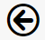 | Back | Use instead of the browser’s built-in back button.
 | Refresh | Use instead of the browser’s built-in refresh button.
 | Properties | Click to view properties.
 | Trash Can | Delete an item.
 | Up arrow | Closes a group of controls.
 | Down arrow | Opens a group of controls.
 | Left arrow | Decreases the width of browser space used to display property groups.
 | Right arrow | Increases the width of browser space used to display property groups.

